WIRELESS SENSOR NETWORKS AND MOBILE COMMUNICATION PRACTICAL-1

NAME: Neeraj Appari T073

Aim: Understanding the Sensor Node Hardware. (For Eg. Sensors, Nodes (Sensor mote), Base Station, Graphical User Interface.)

Topic: Solar Energy Harvesting for Wireless Sensor Networks

1. Solar energy harvesting that provides an alternative power source for an energy-constrained wireless sensor network (WSN) node.
2. The solar cell performance depends on the intensity of sunlight, where the average power generated by the solar panels is about 220 mW-750 mW.
3. Solar cell efficiency, DC-DC power converters, Maximum Power Point Tracking algorithms, solar energy prediction algorithms, microcontrollers, energy storage (battery/supercapacitor), and various design costs for SEH-WSNs.
4. The polycrystalline solar panel type with size of 180 × 81 × 1.55 mm and 70 × 55 × 3 mm was tested to provide energy supply for the node comprising one microcontroller, Xbee transceiver, and sensor component.
5. The output voltage of solar cell is ranging between 2V-6V.
6. During sunrise and sunset, the sunlight is weak and the incidence angle (θ) is less direct, the power generated is also less.

Benefits:

1. Solar energy is the eternal power source.
2. Solar energy is unpolluted and does not harm the atmosphere.
3. Highest achieved power density 10–15 mW/cm2 as compared to all other renewable
4. Solar energy is flexible, i.e., it can be utilized for low-voltage applications like hand-held calculators, watches, and wireless embedded microcontroller devices as well as high power applications like motor traction, water geysers, power plants, and satellite transponders.

Sensor Node:

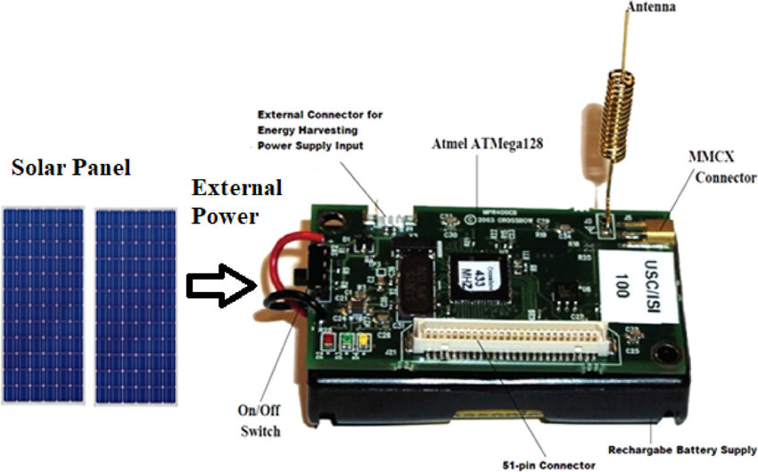

Block Diagram: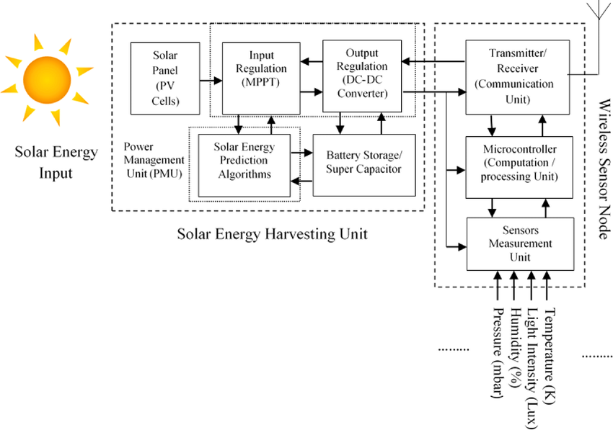

WIRELESS SENSOR NETWORKS AND MOBILE COMMUNICATION

PRACTICAL-2

NAME: Neeraj Appari T073

AIM: Exploring and understanding TinyOS computational concepts: - Events, Commands and Task.

- nesC model

- nesC Components

TinyOS

TinyOS is an embedded, component-based operating system and platform for low-power wireless devices, such as those used in wireless sensor networks (WSNs), smartdust, ubiquitous computing, personal area networks, building automation, and smart meters.

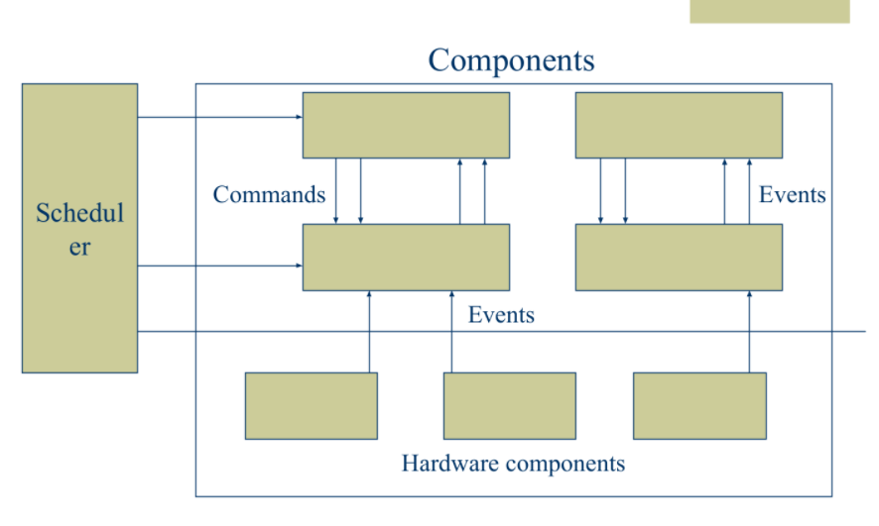

Tasks

1. Perform the primary computation work
2. Atomic with respect to other tasks, and run to completion, but can be pre-empted by events
3. Allow the OS to allocate a single stack assigned to the currently executing task
4. Call lower-level commands
5. Signal higher level events

Commands

1. Non-blocking requests to lower-level components
2. Deposit request parameters into a component’s
3. frame, and post a task for later execution
4. Can also invoke lower-level commands, but cannot block
5. To avoid cycles, commands cannot signal events
6. Return status to the caller

Events

1. Event handlers deal with hardware events (interrupts) directly or indirectly
2. Deposit information into a frame
3. Post tasks
4. Signal higher level events
5. Call lower-level commands

NesC

NesC Programming Model

1. Programs are built out of components
2. Two types of components: Modules: Implement program logic Configurations: Wire components together
3. Components use and provide interfaces
4. Components are wired together by connecting interface users with interface providers
5. Interfaces contain definitions of 1) Commands 2) Events
6. Components implement the event handlers they use and the commands they provide.

NesC Components :

Anecdotally, nesC’s component model has been invaluable for event-driven sensor applications. The success of the component model is shown by the way in which components are used in the TinyOS code; applications are small, and make use of a large number of reusable components. Moreover, nesC’s component model makes it possible to pick and choose which parts of the OS are included with each application

Wireless Sensor Networks and Mobile Communication Practical 4

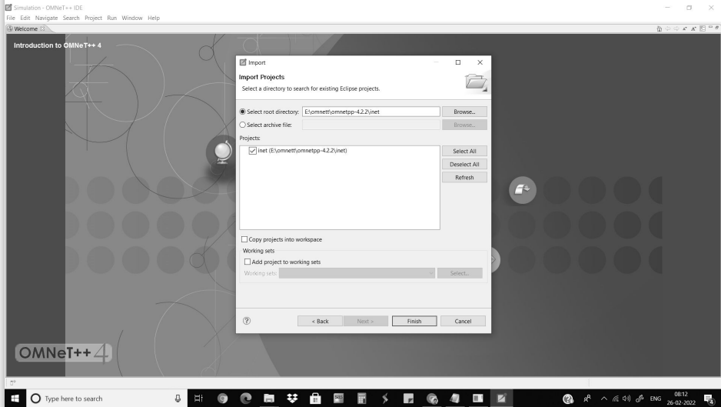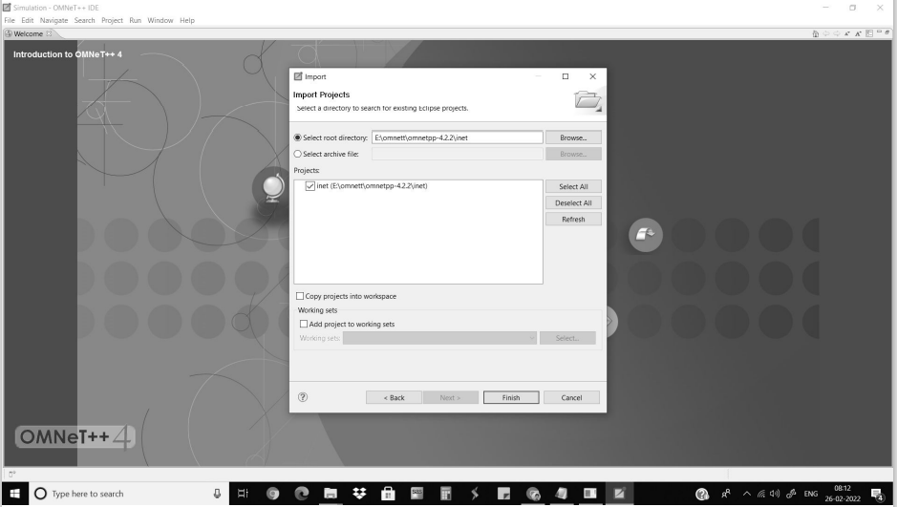

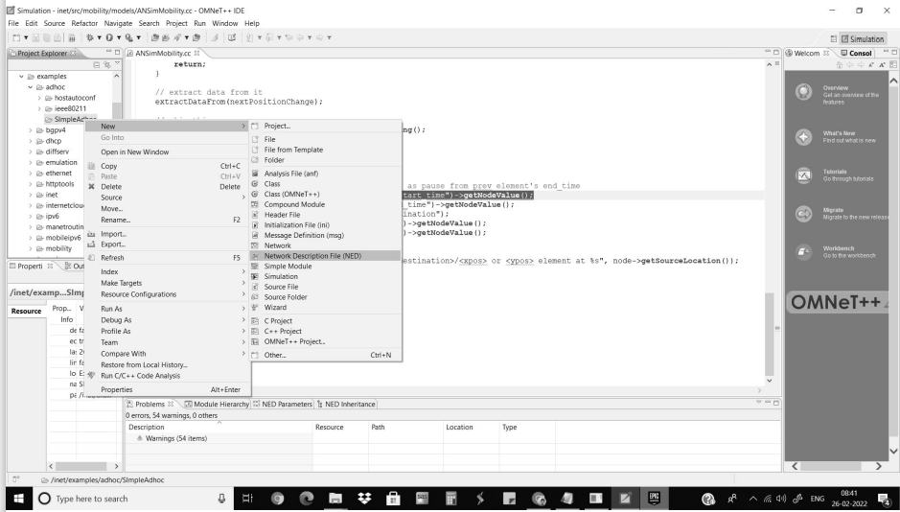

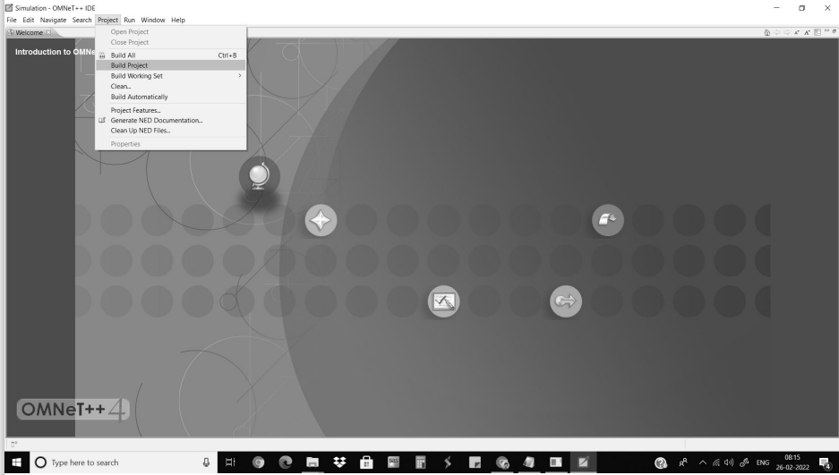

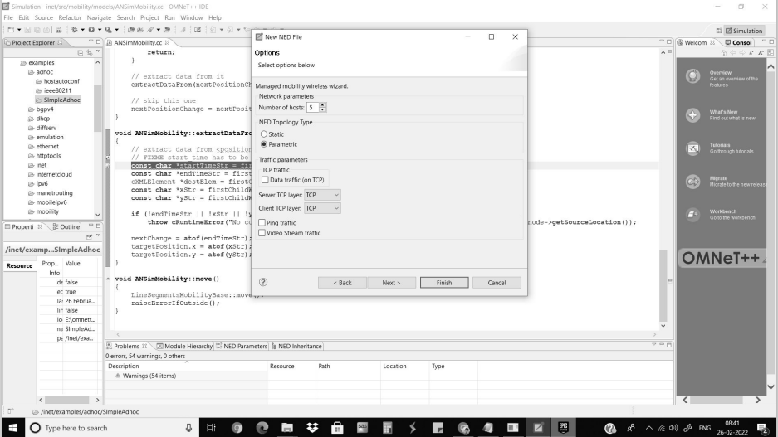

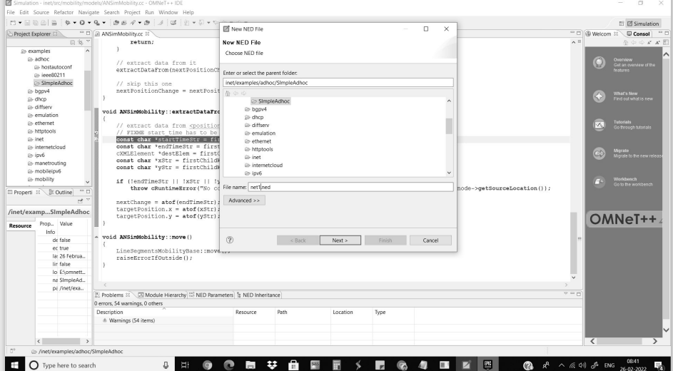

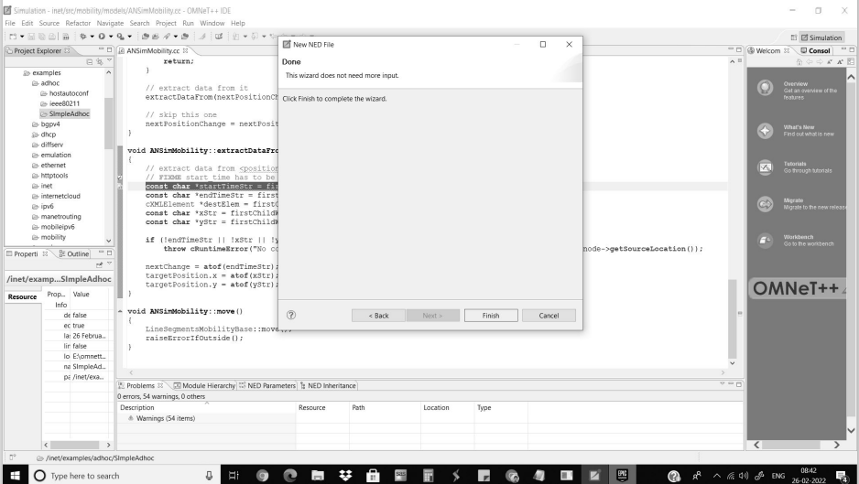

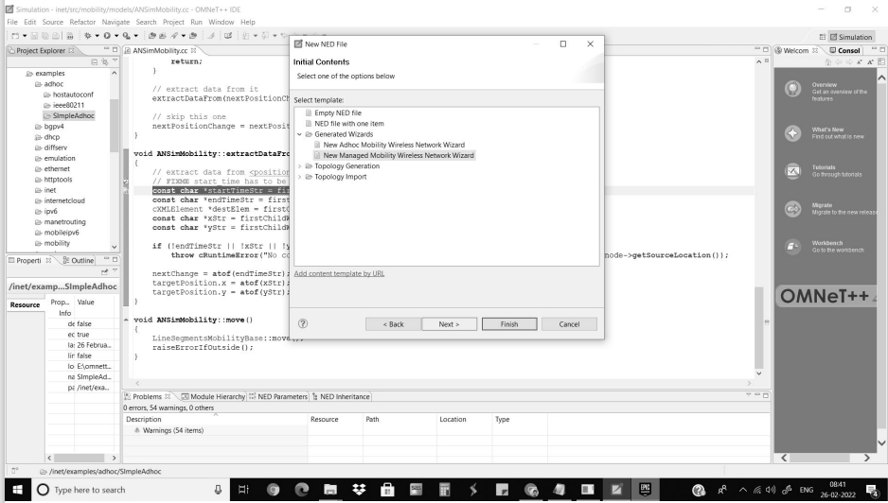

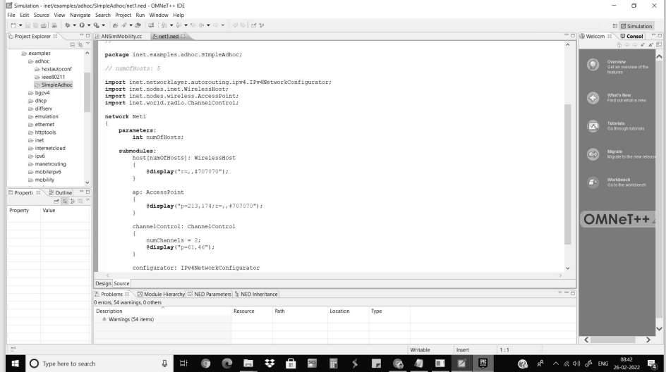

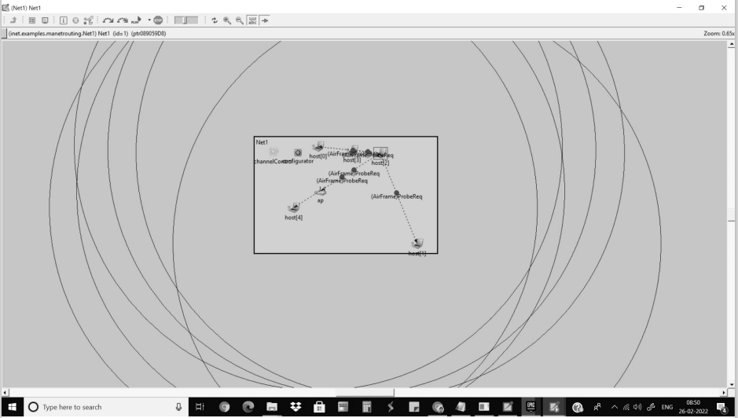

Neeraj Appari T073

Wireless Sensor Networks and Mobile Communication Practical 5

Aim-Understanding, Reading and Analysing Routing Table of a network.

Part 1-

1)Open Cisco Packet Tracer and add 2 PCs and 2 routers and connect them.

2)Click on the PC0 and give IP dress and Gateway IP address.

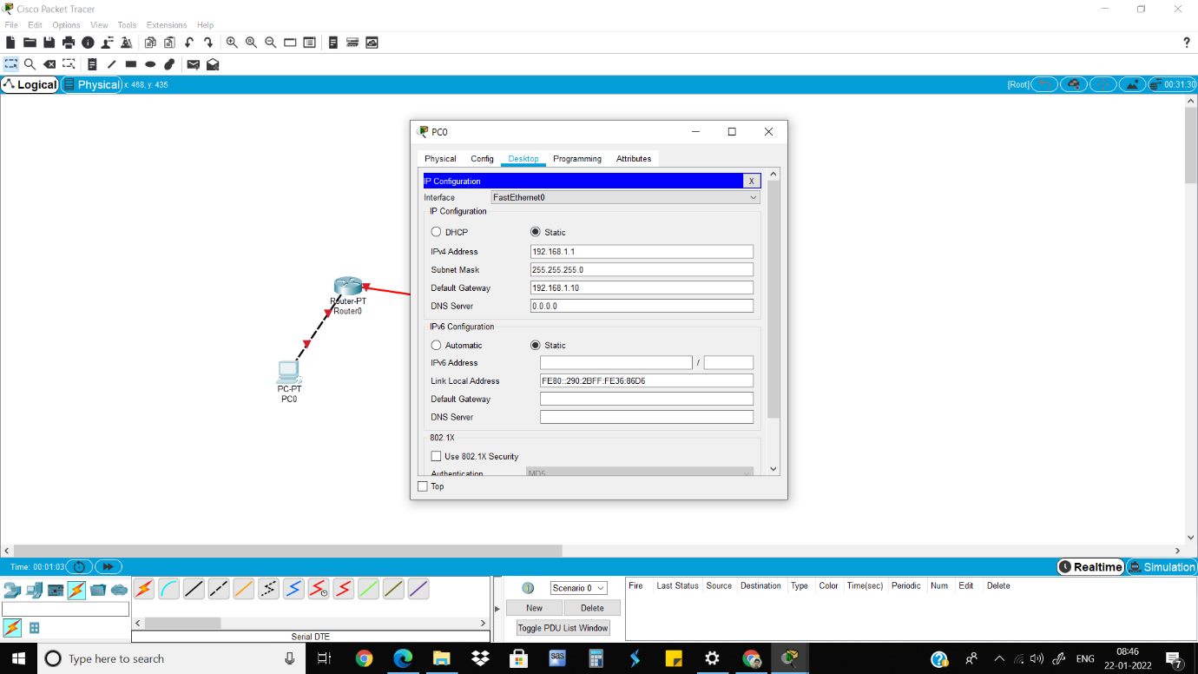

3)Click on the Router0 which is connected to PC0, turn it on and give IP address.

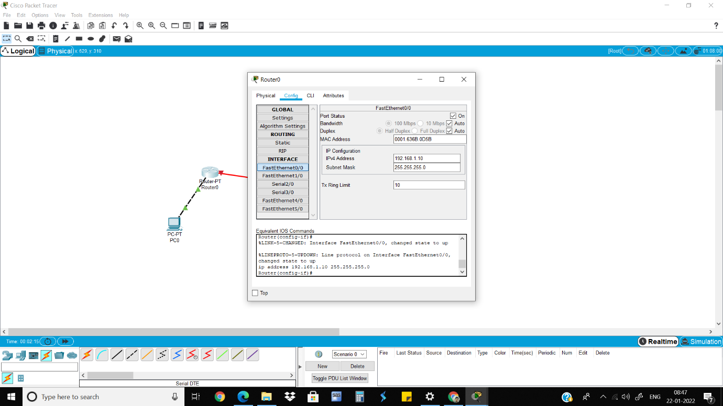

4)Go to RIP and add the gateway IP address.

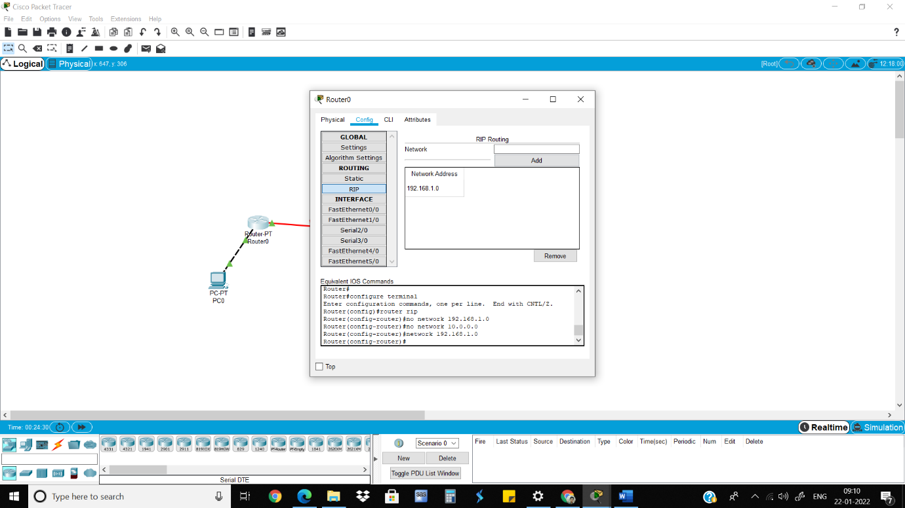

5)Do the same steps for PC2.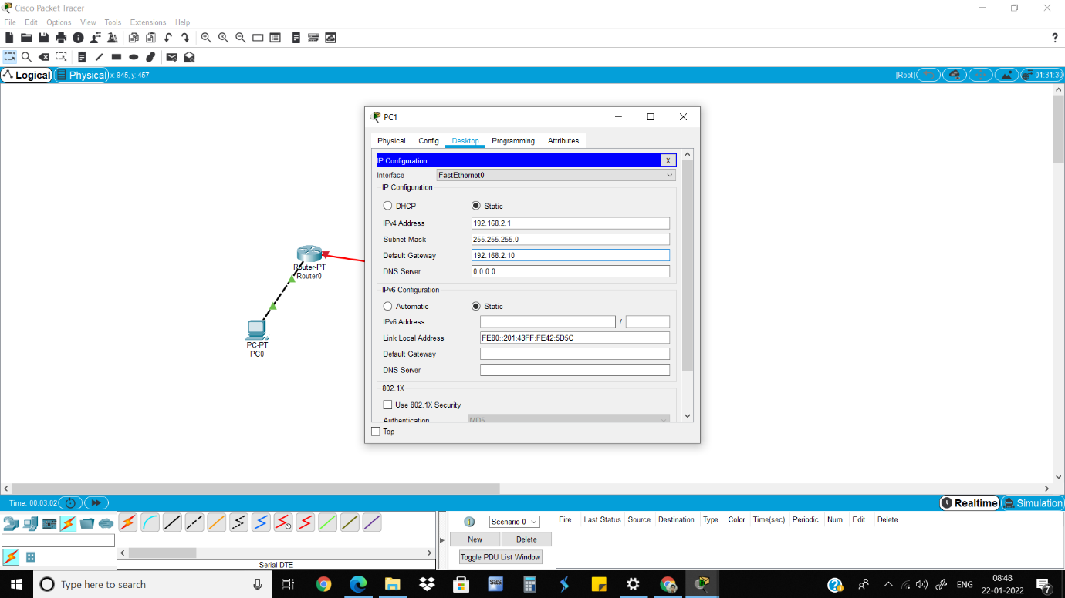

6)Do the same steps for Router1 as done in Router0.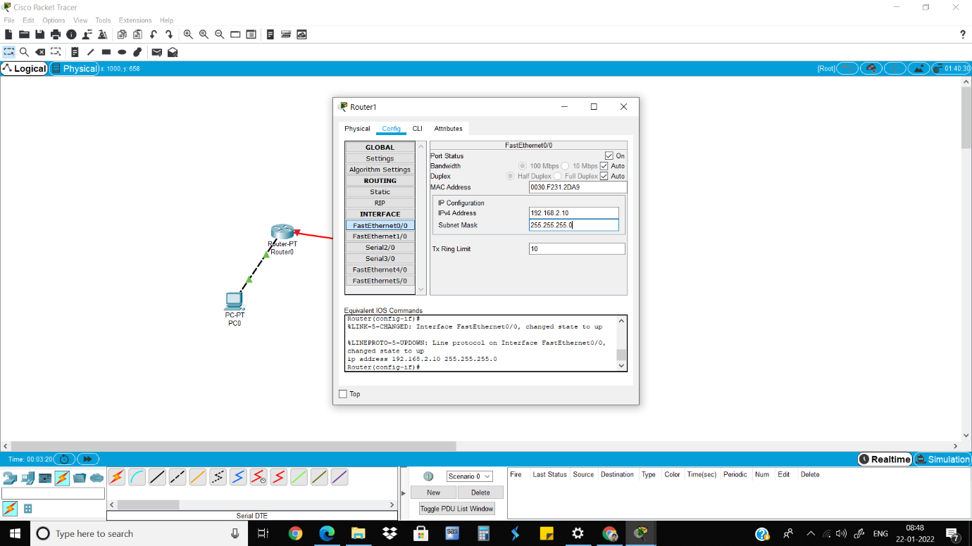

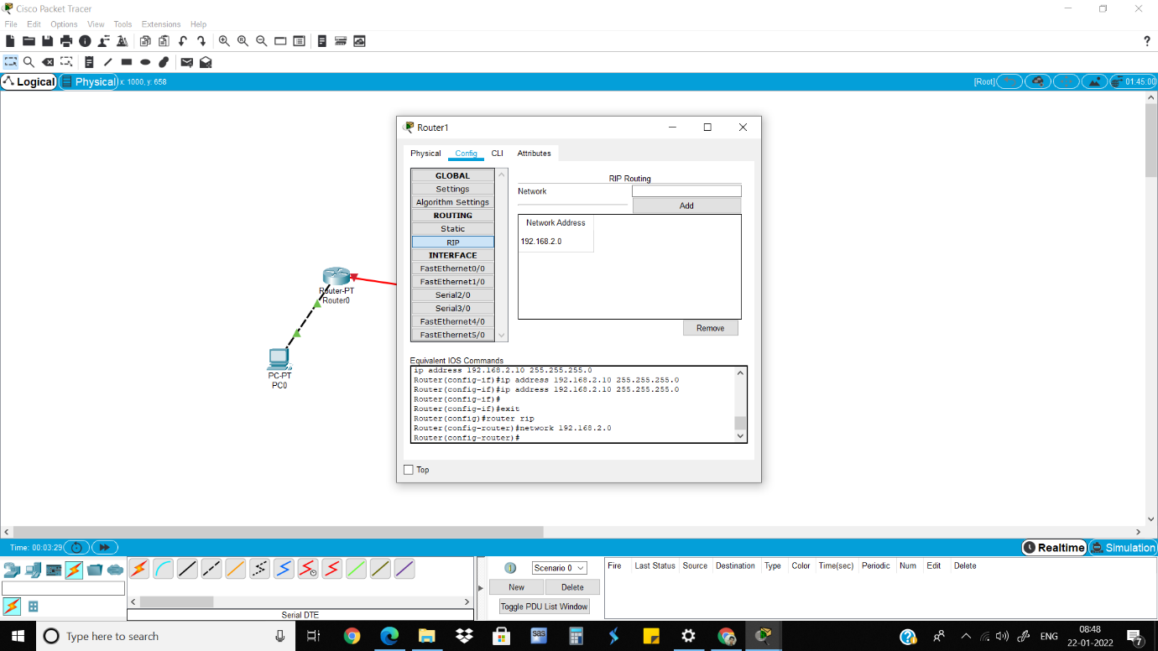

7)Go to the Serial2/0 of Router0, turn on the port, give clock rate and give the IP address.

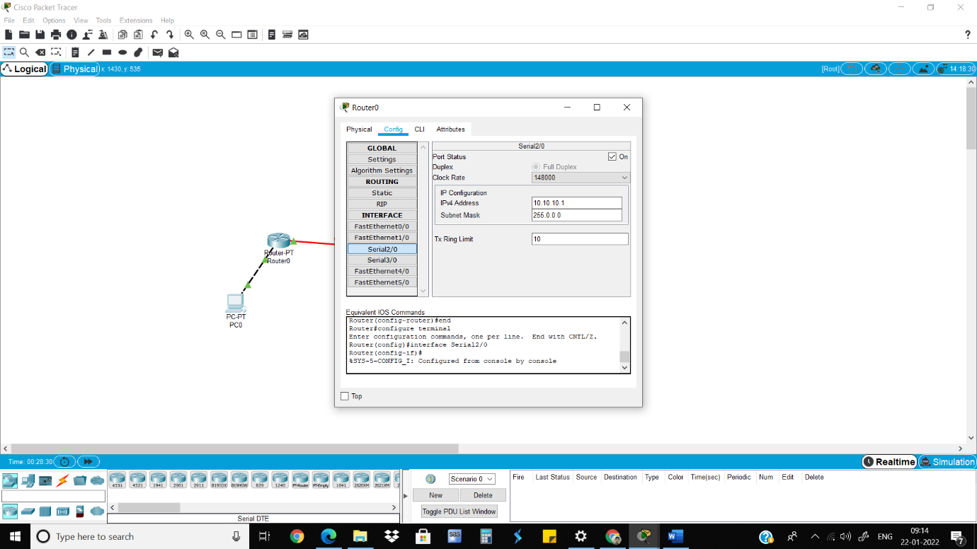

8) Go to Rip and add the IP address. 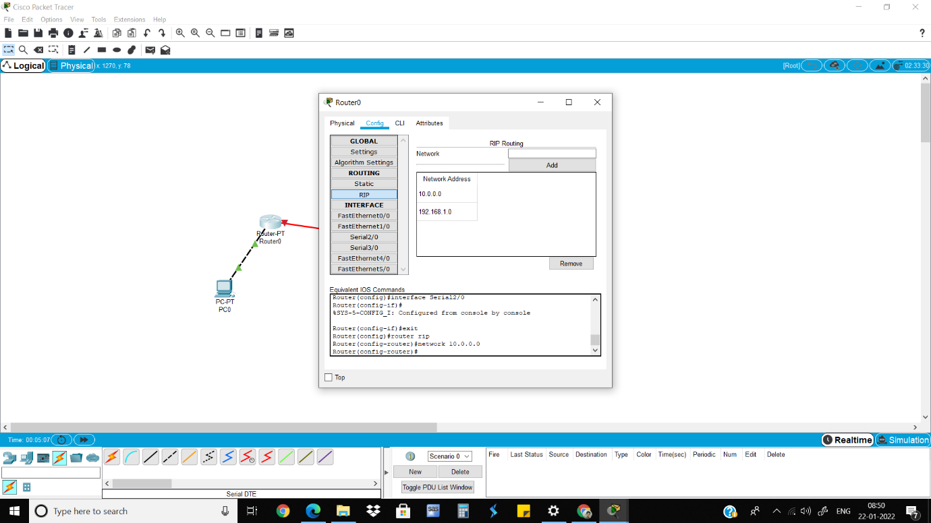

9)Do the same steps for Router1.

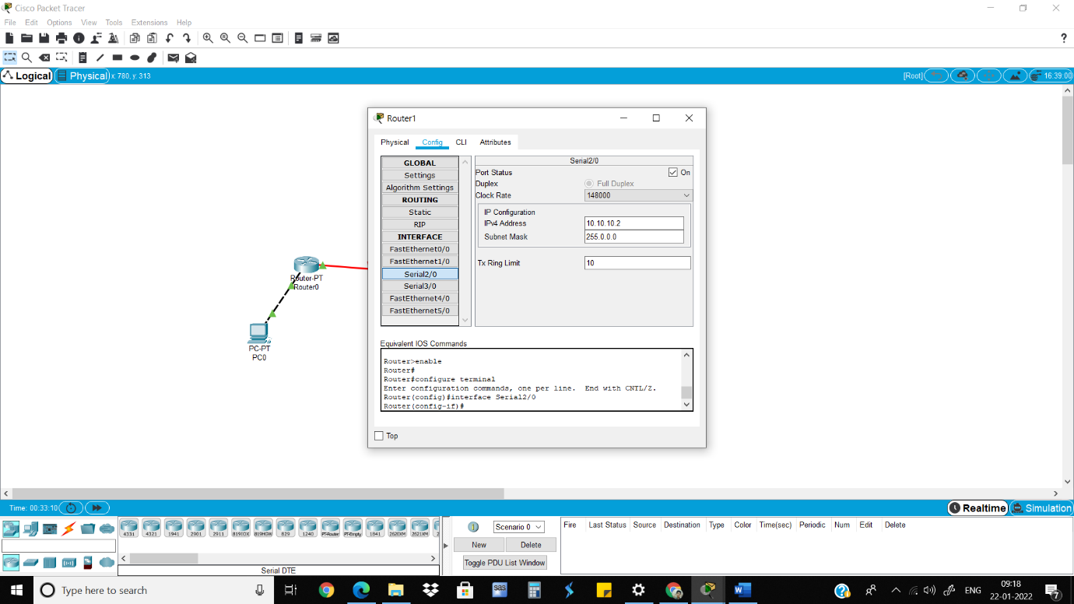

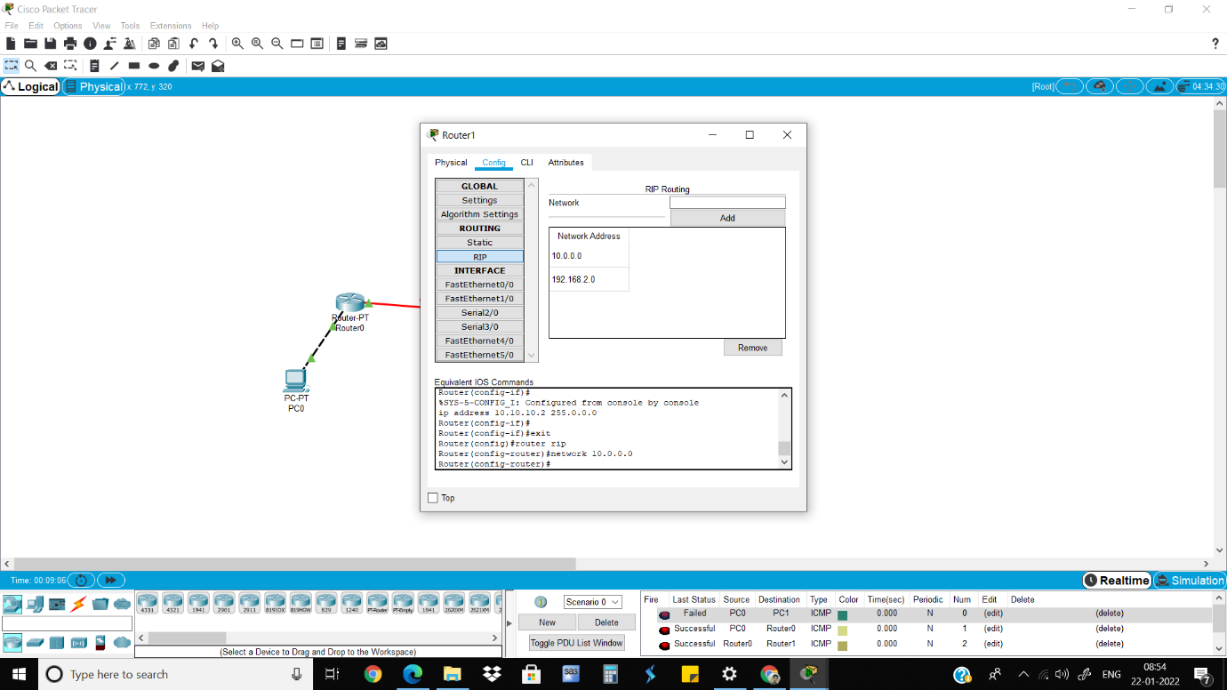

10)Send packets from PC0 to PC1 and vice versa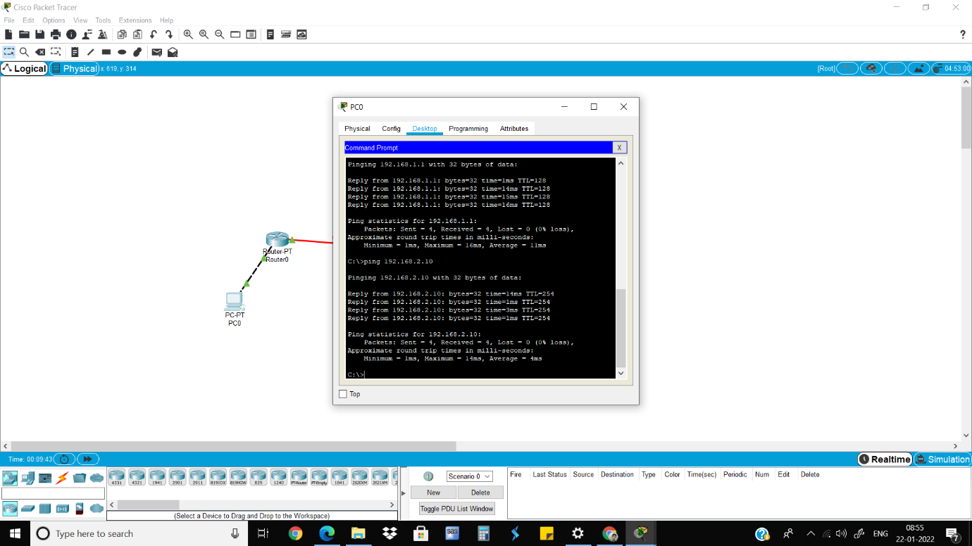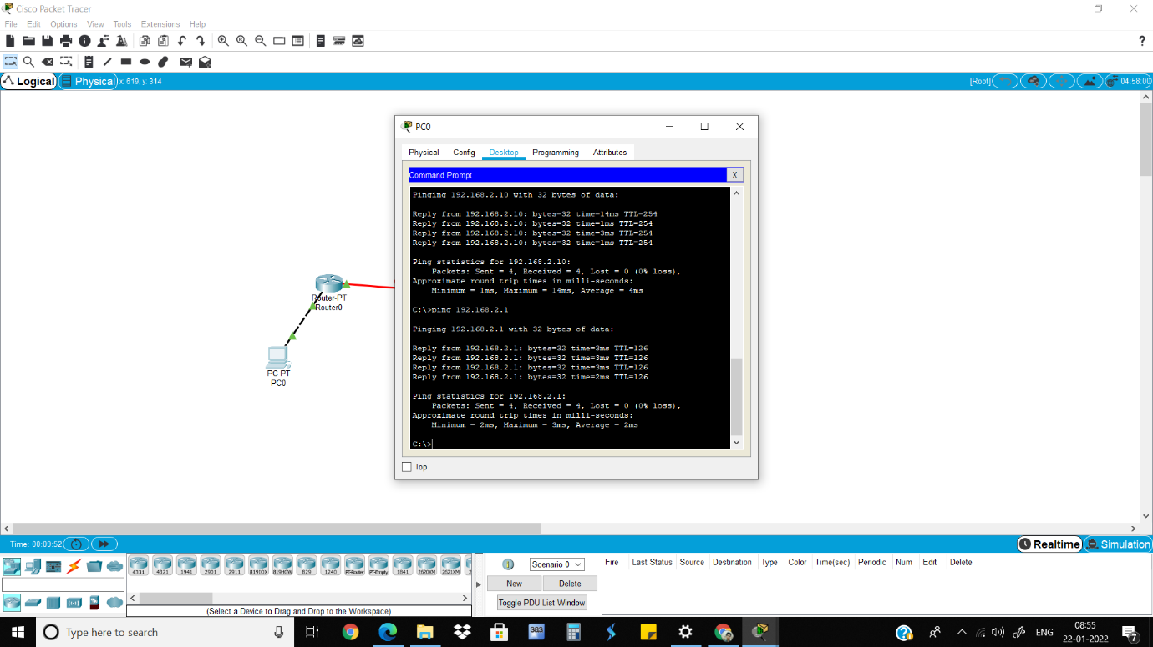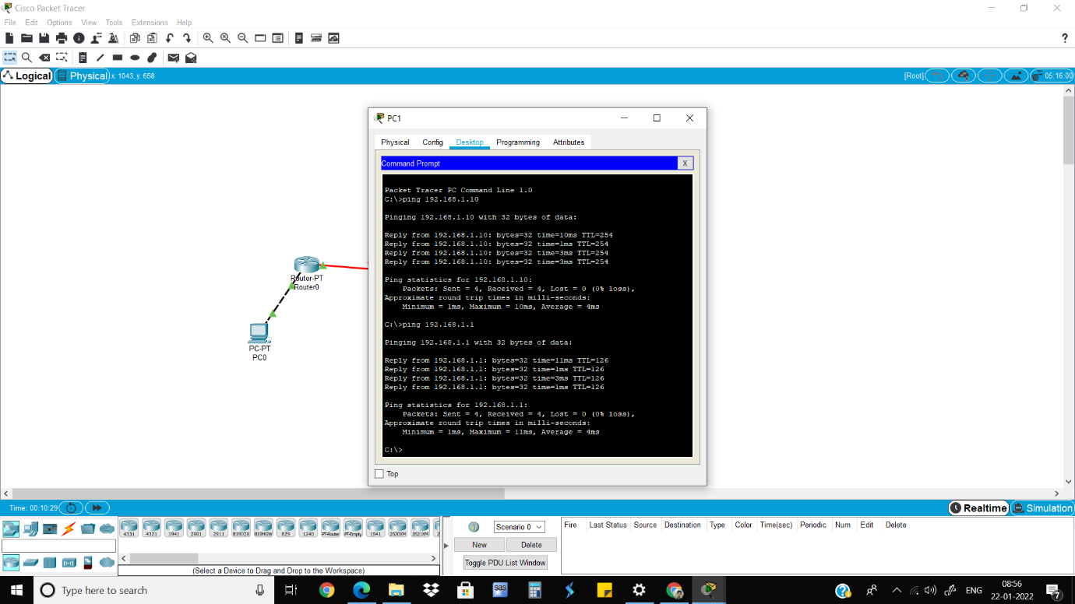

Part 2

1) Add 2 PCs, 2 routers, 2 servers and 2 switches and connect them.

2) Click on the PC0 and give IP dress and Gateway IP address.

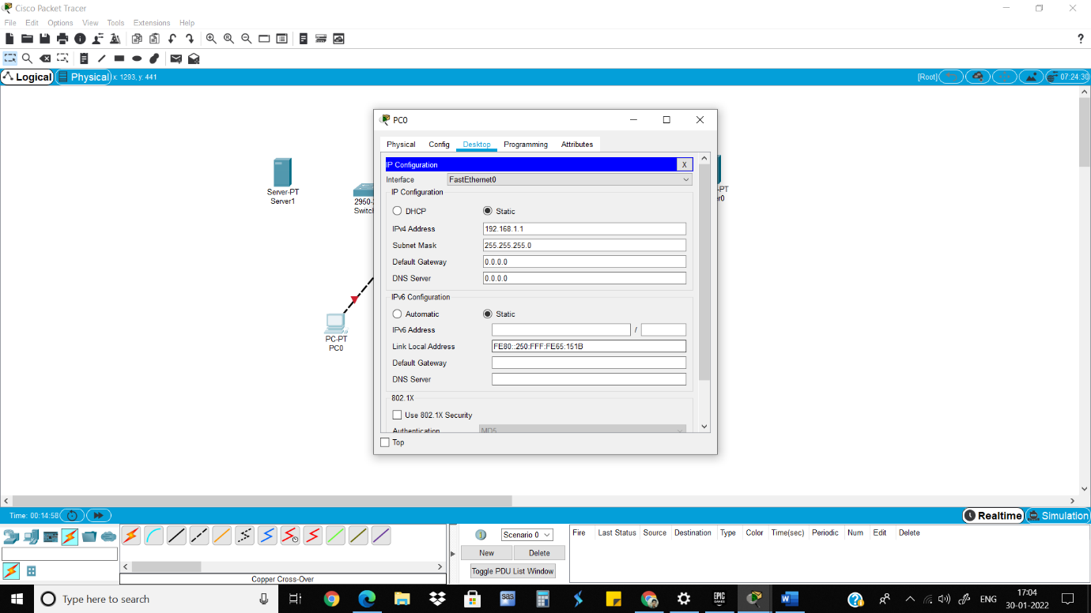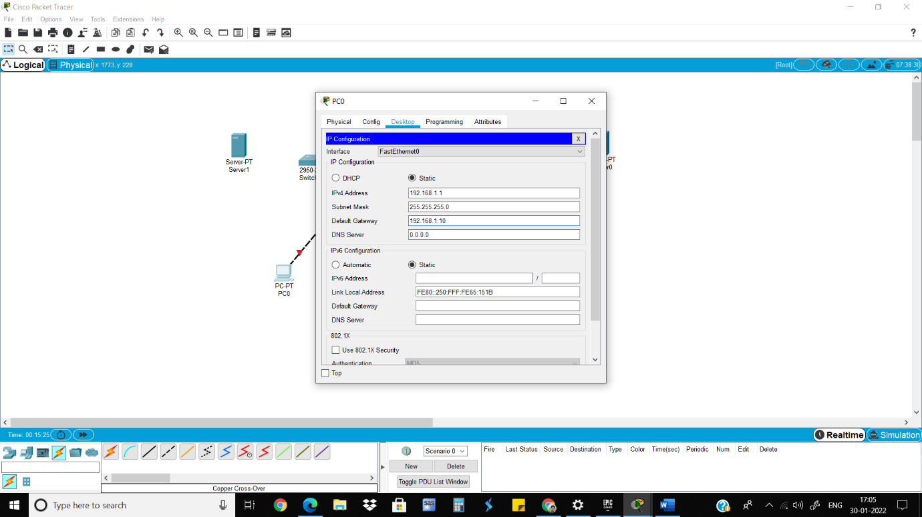

3) Click on the Router0 which is connected to PC0, turn it on and give IP address and Go to RIP and add the gateway IP address.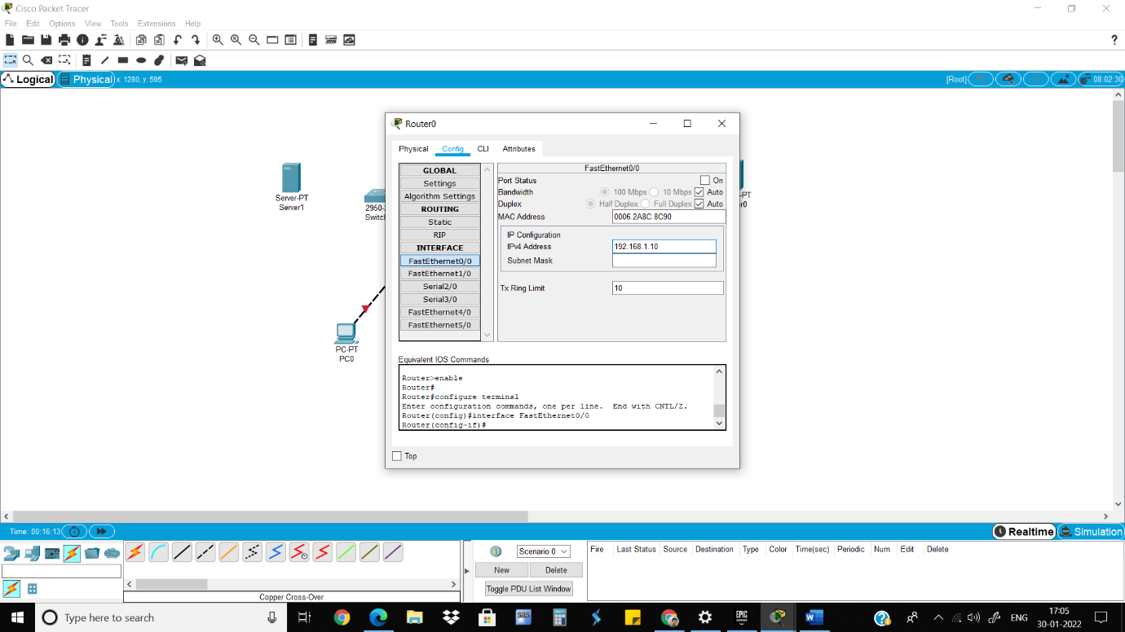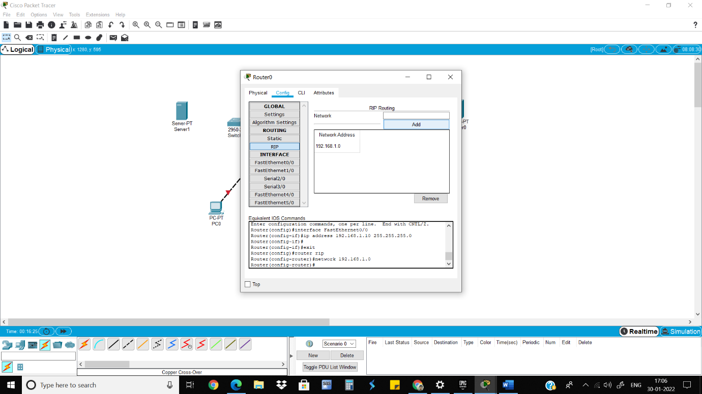

4) Click on the Server1 and give IP dress and Gateway IP address.

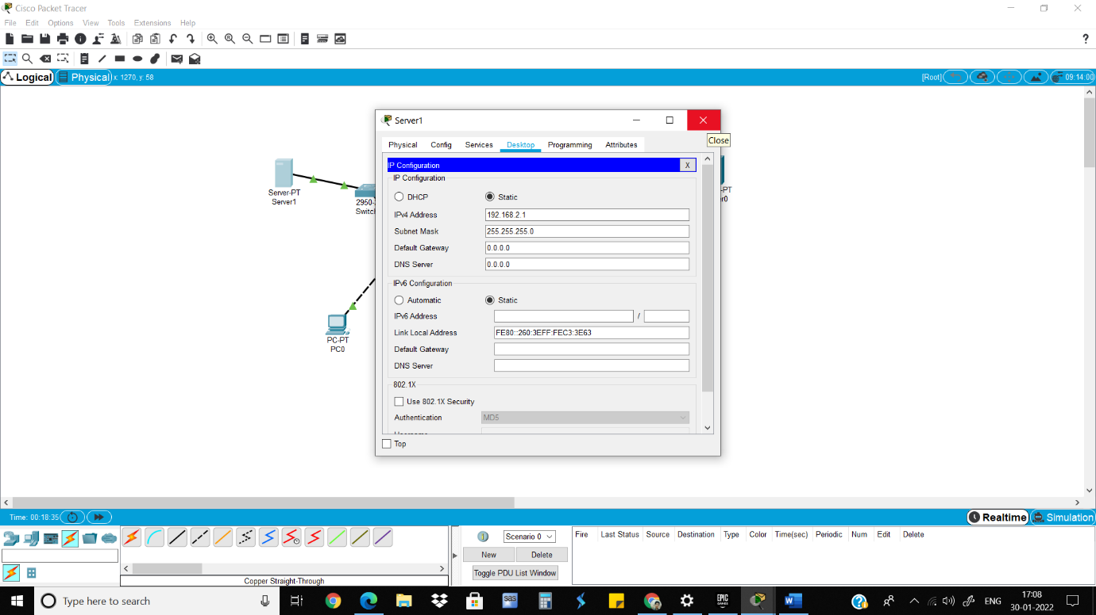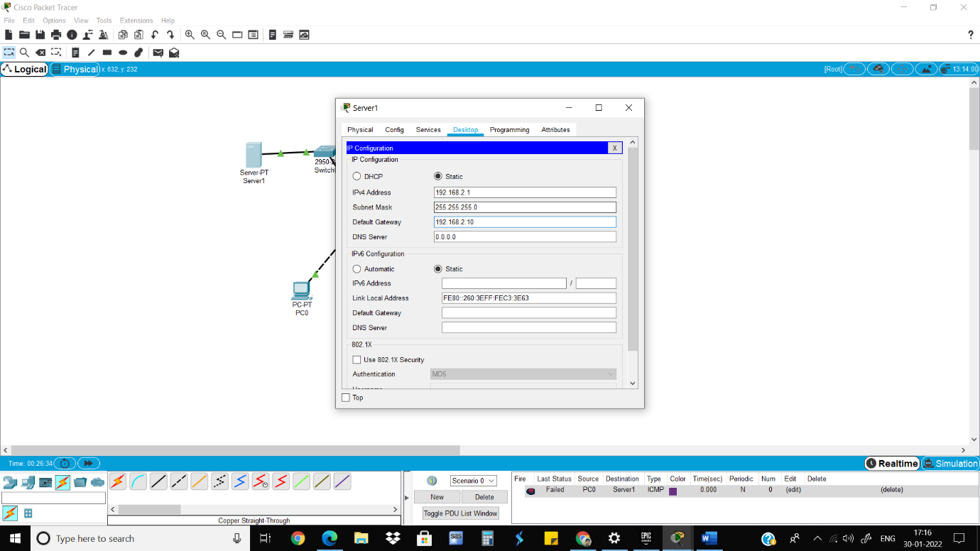

5) Click on the Router0 which is connected to PC0, turn it on and give IP address and Go to RIP and add the gateway IP address. 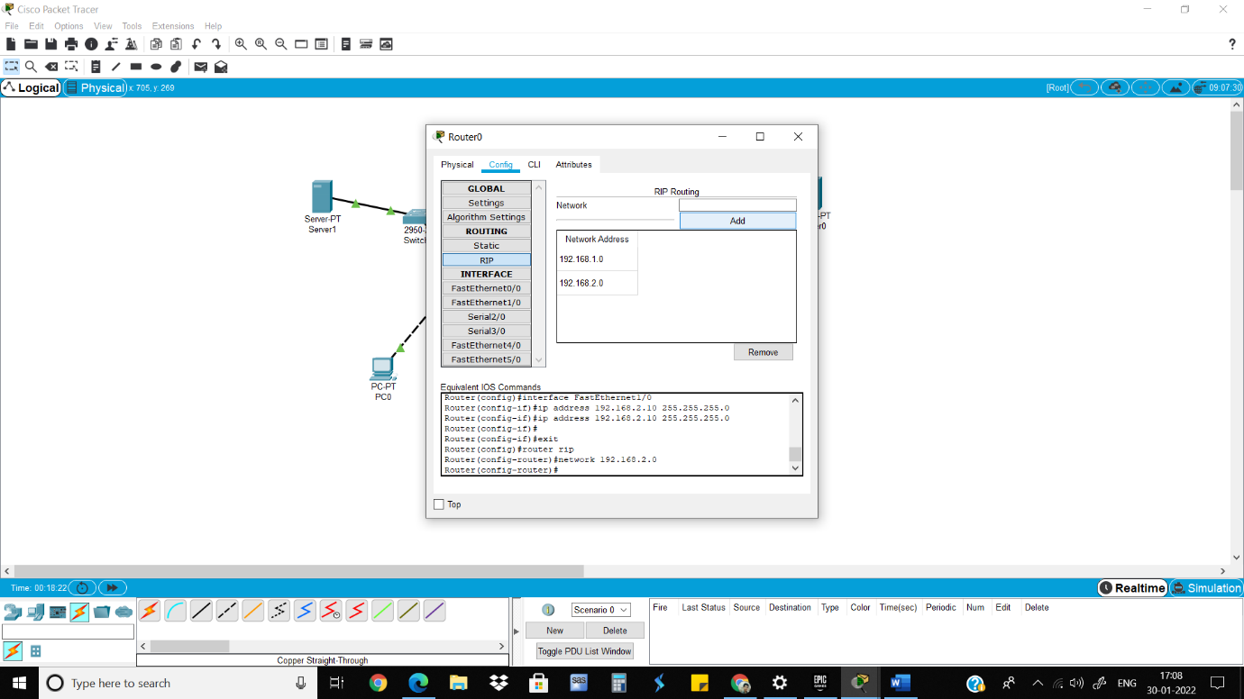

6)Do the same steps on the other side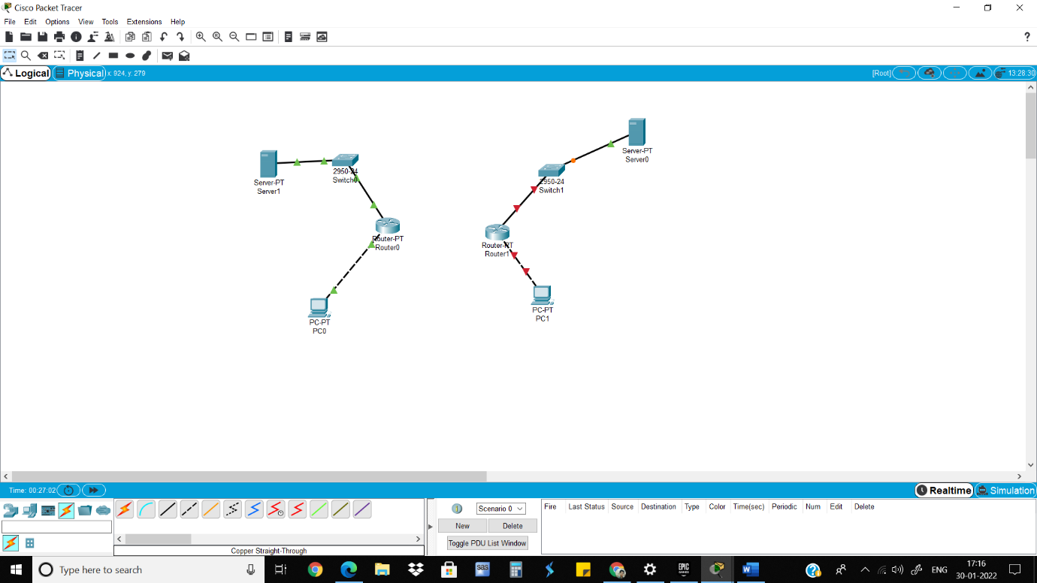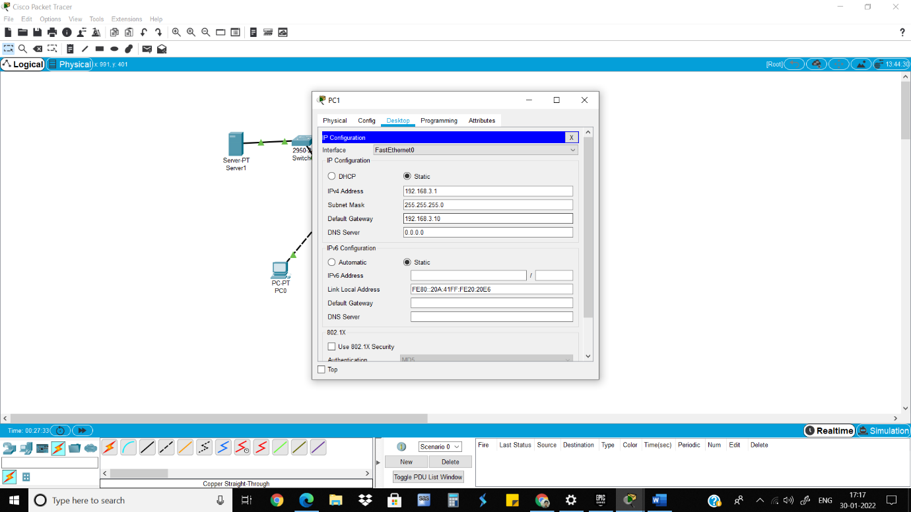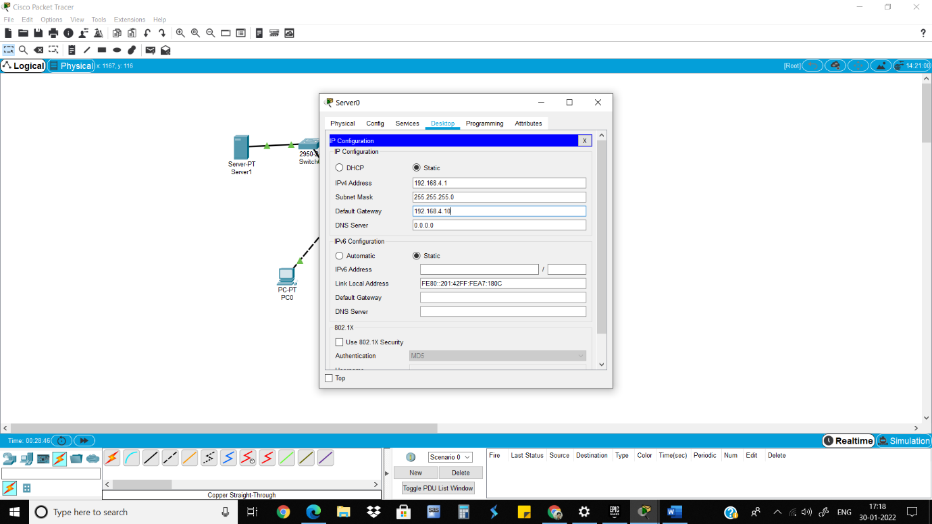

7)Now that PC and servers are connected on each side without routers being connected ping them.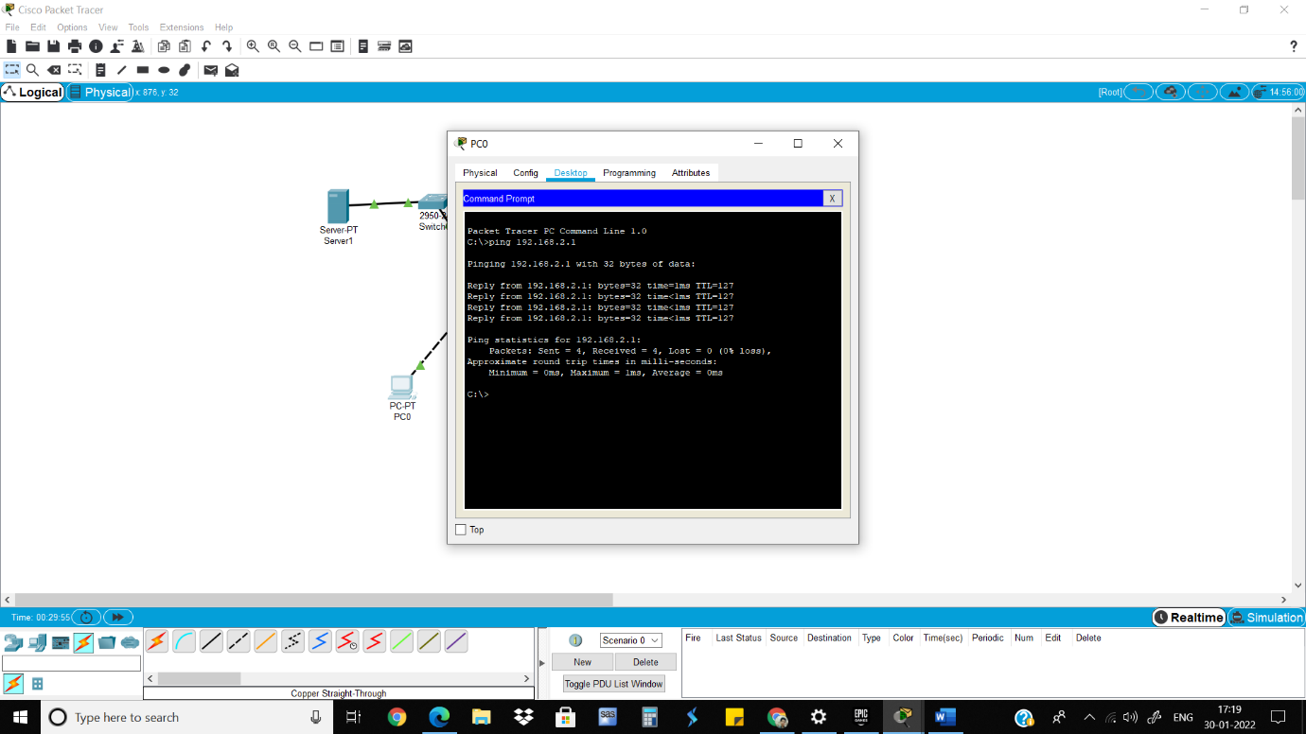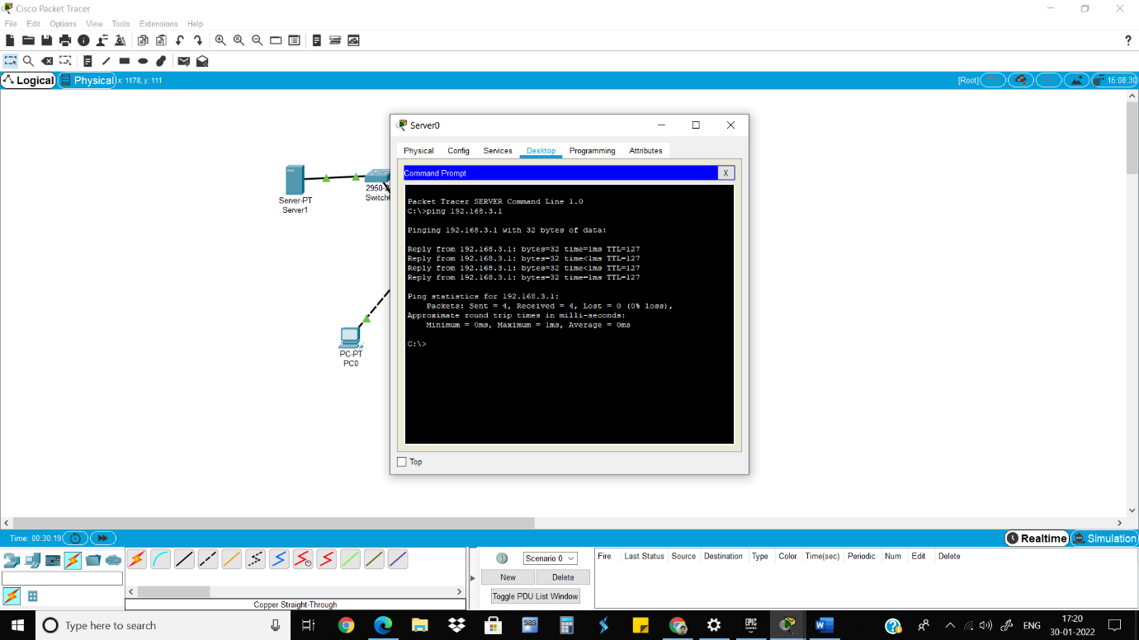

8) Go to the Serial2/0 of Router0, turn on the port, give clock rate and give the IP address and add in RIP.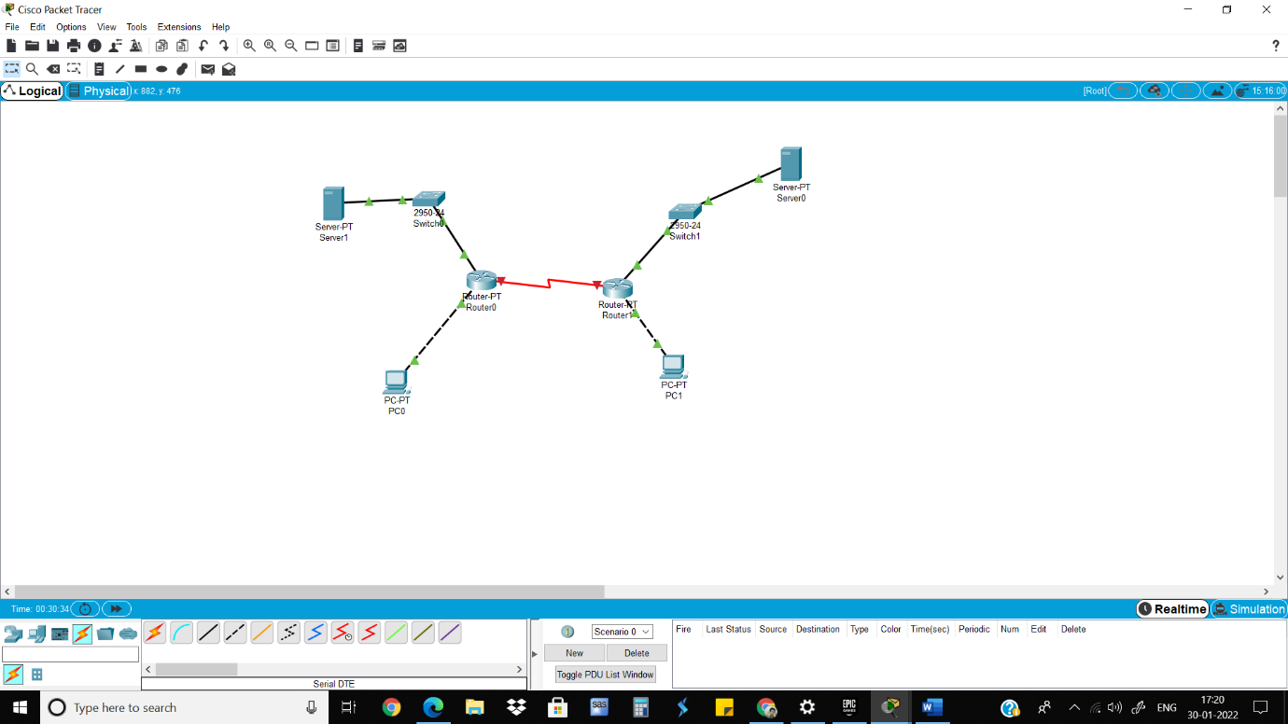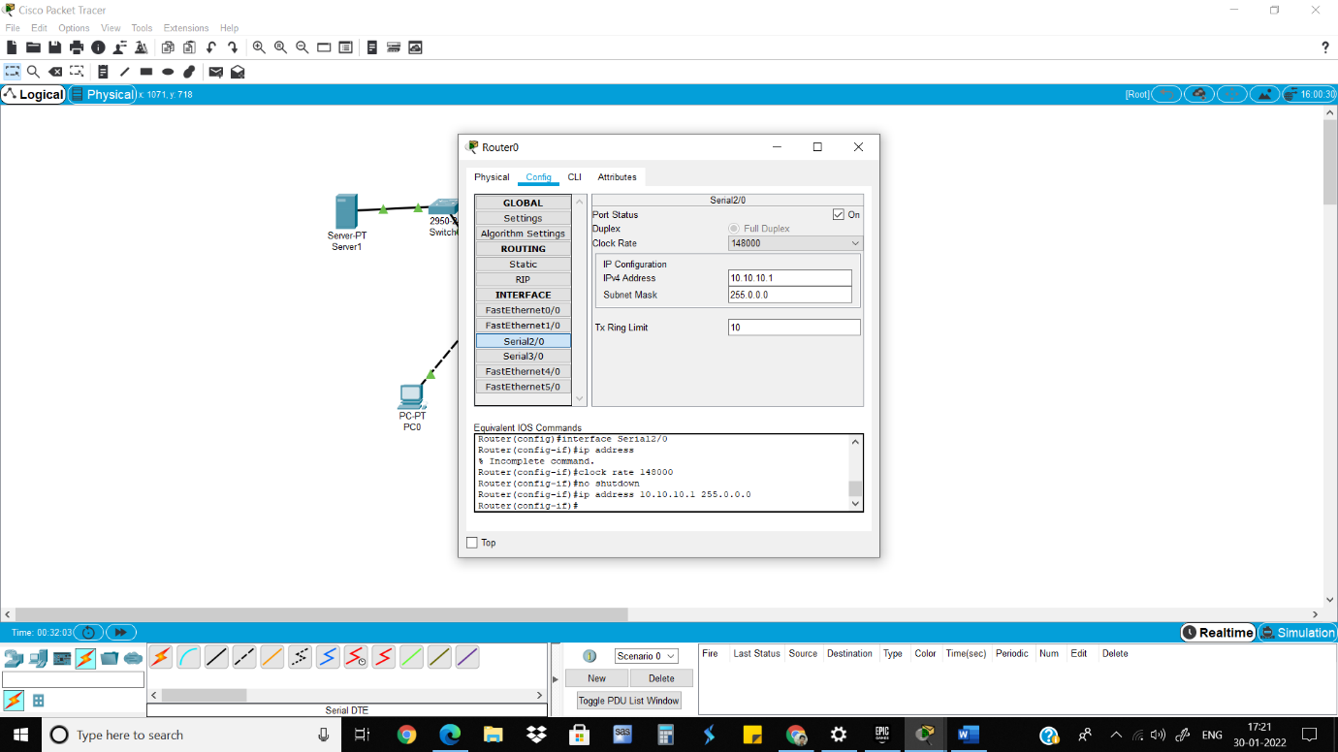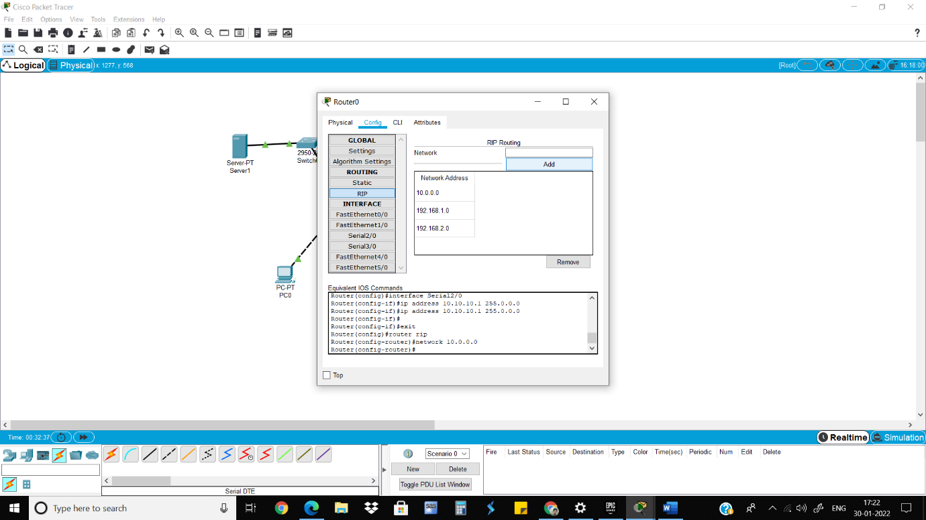

9)Do the same for other side.

10)Now all the pc and servers are connected ping them.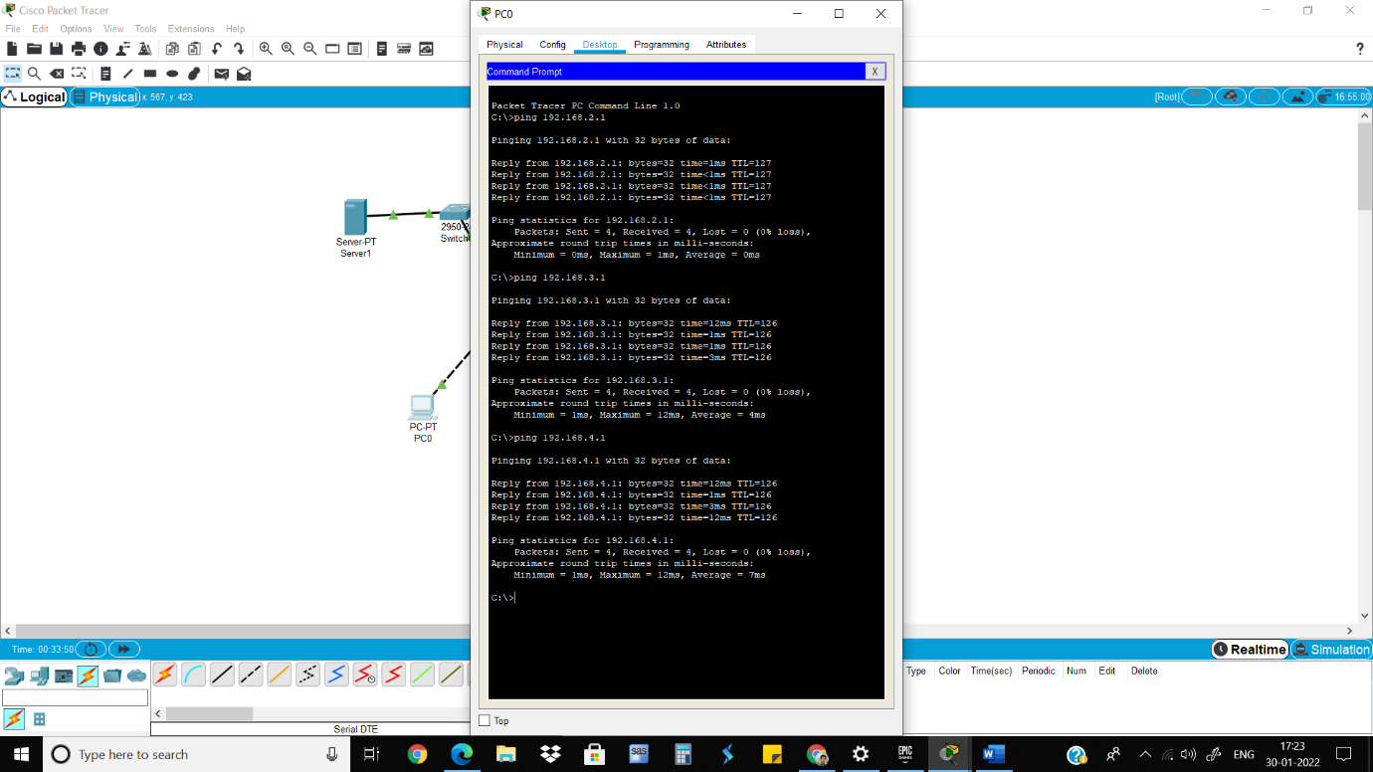

Wireless Sensor Networks and Mobile Communication Practical 6

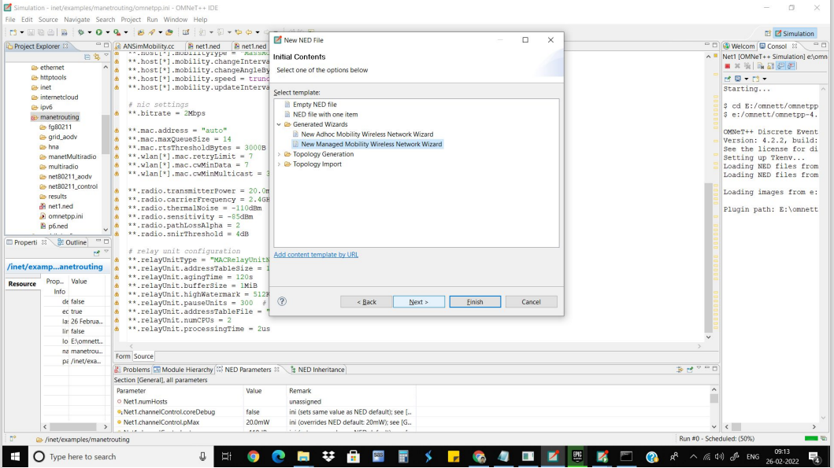

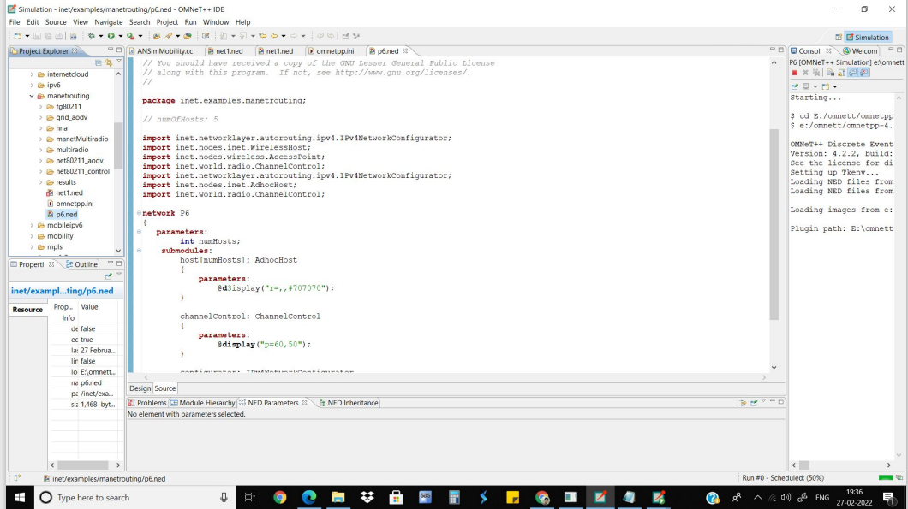

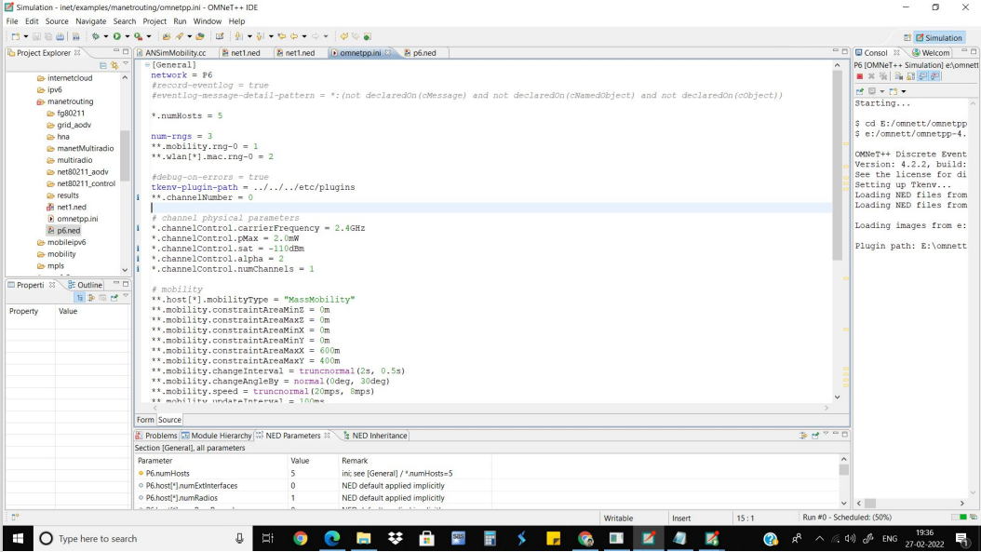 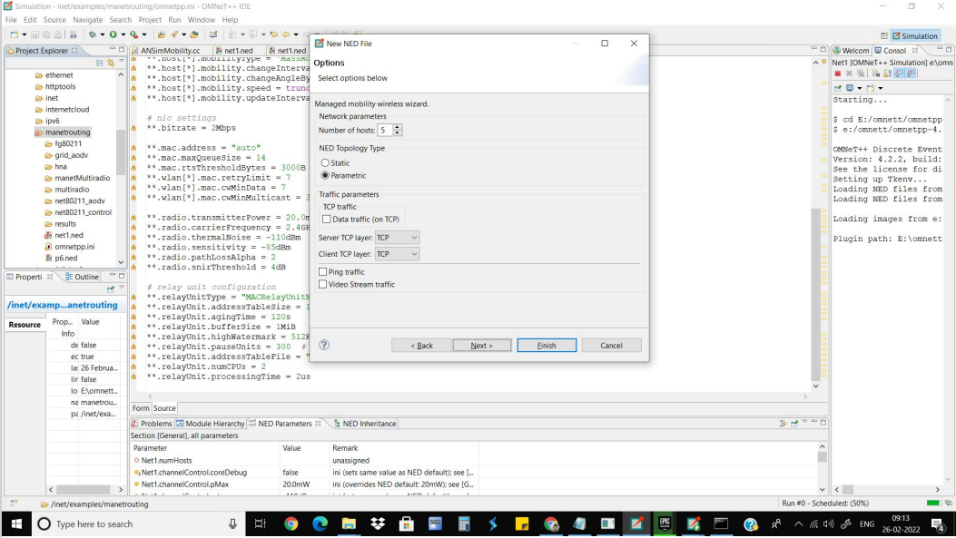

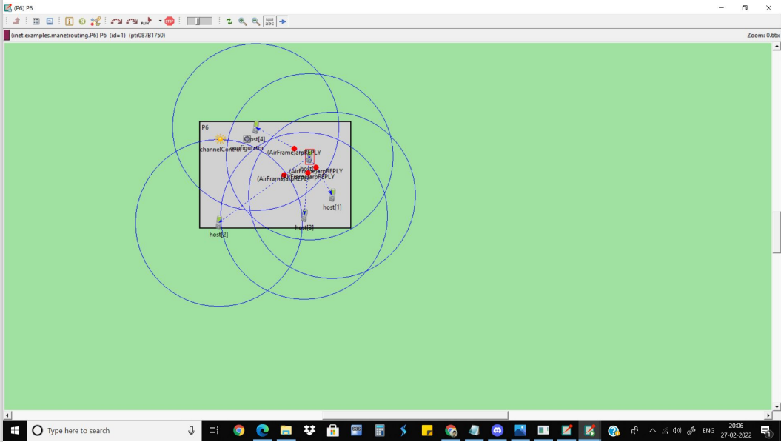

Neeraj Appari T073

Wireless Sensor Networks and Mobile Communication Practical 7

7.1 To demonstrate the Wireless Access within the Access Point

1)Take 3 Access points, 2 PCs, 1 laptop and 1 server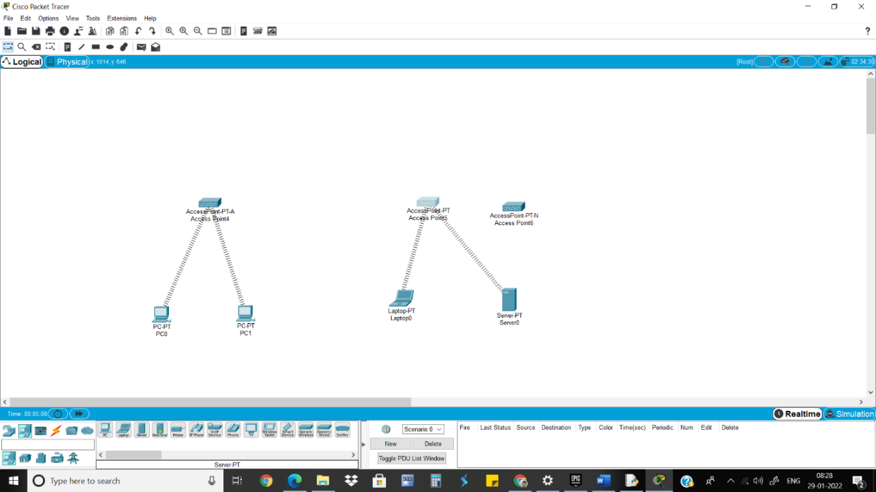

2)Install POST-HOST-NM-1W-A module in PCs and POST-HOST-NM-1W in Laptop and server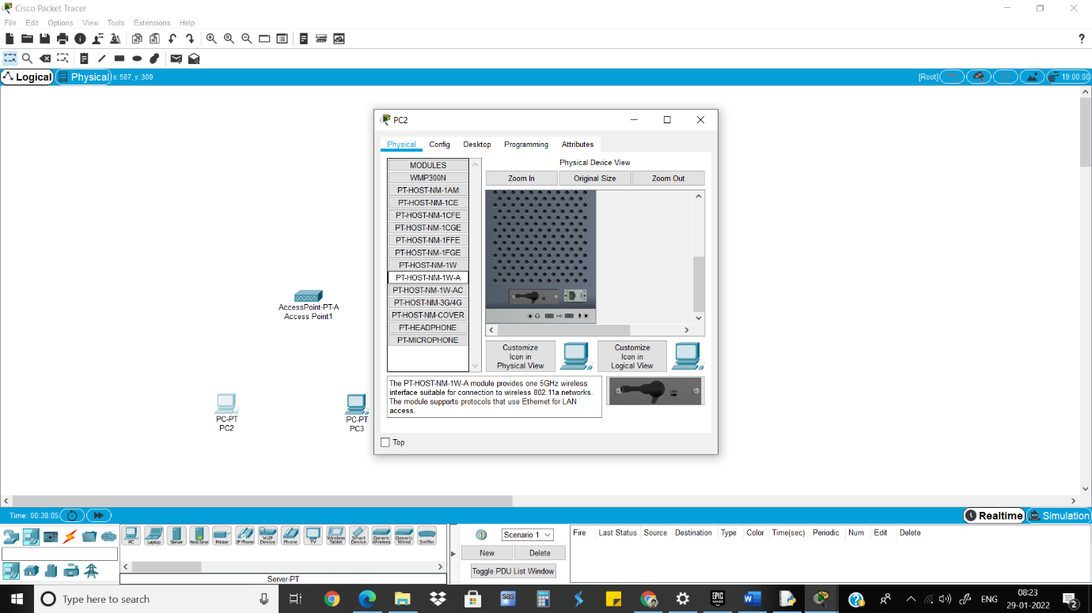

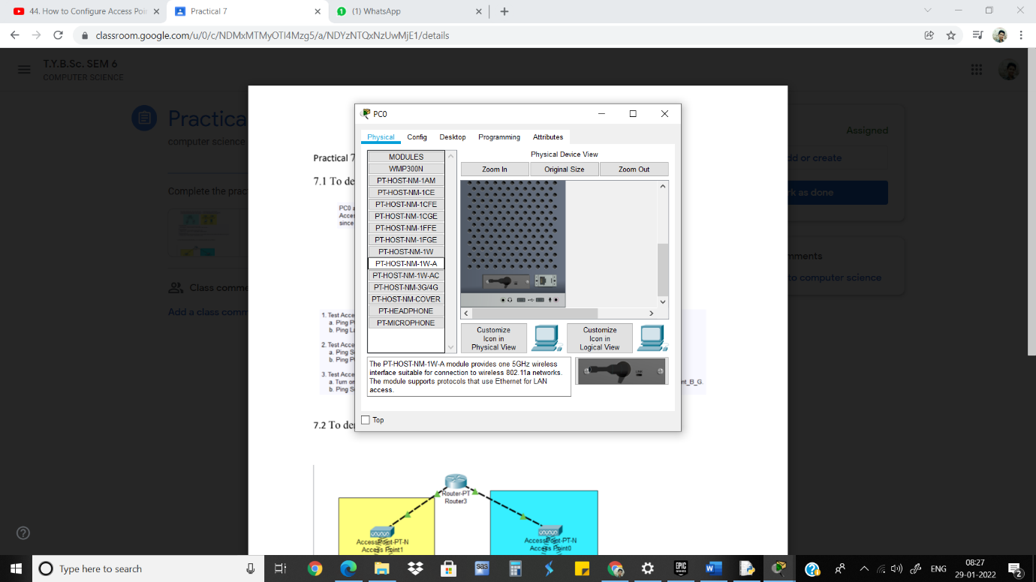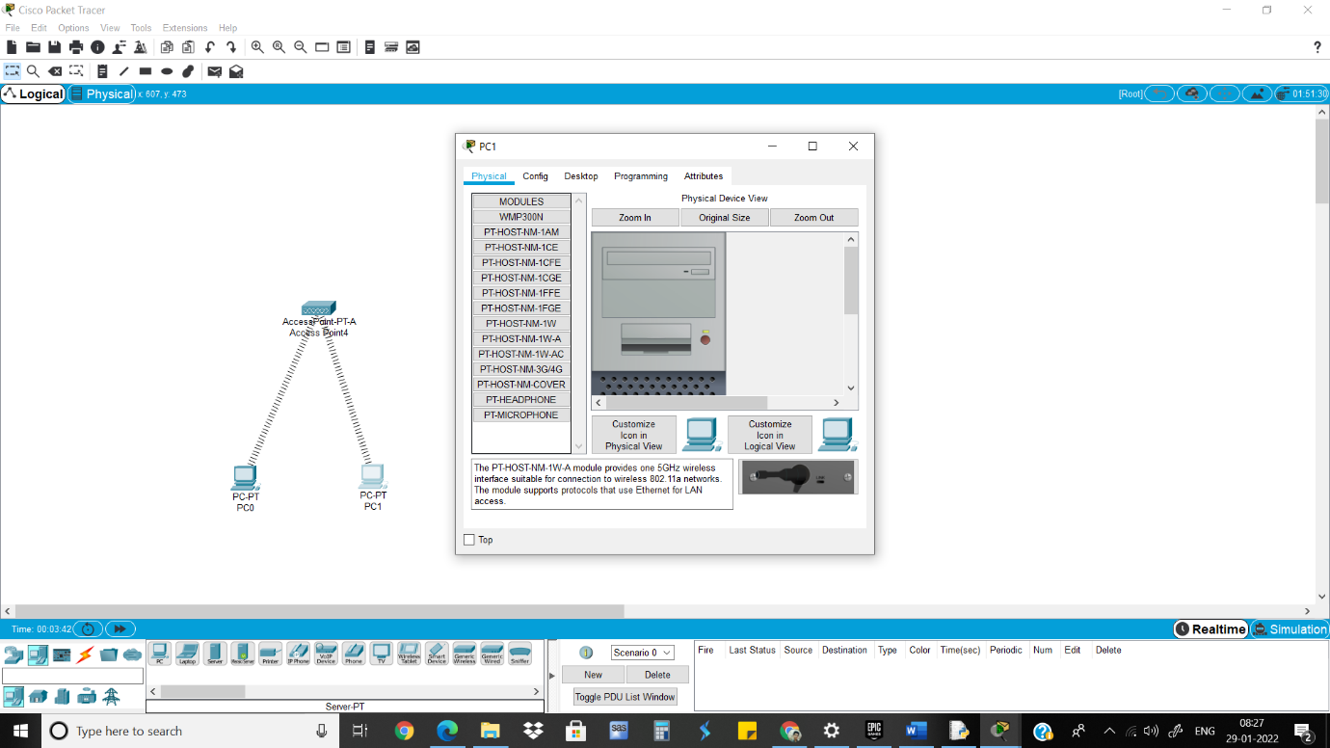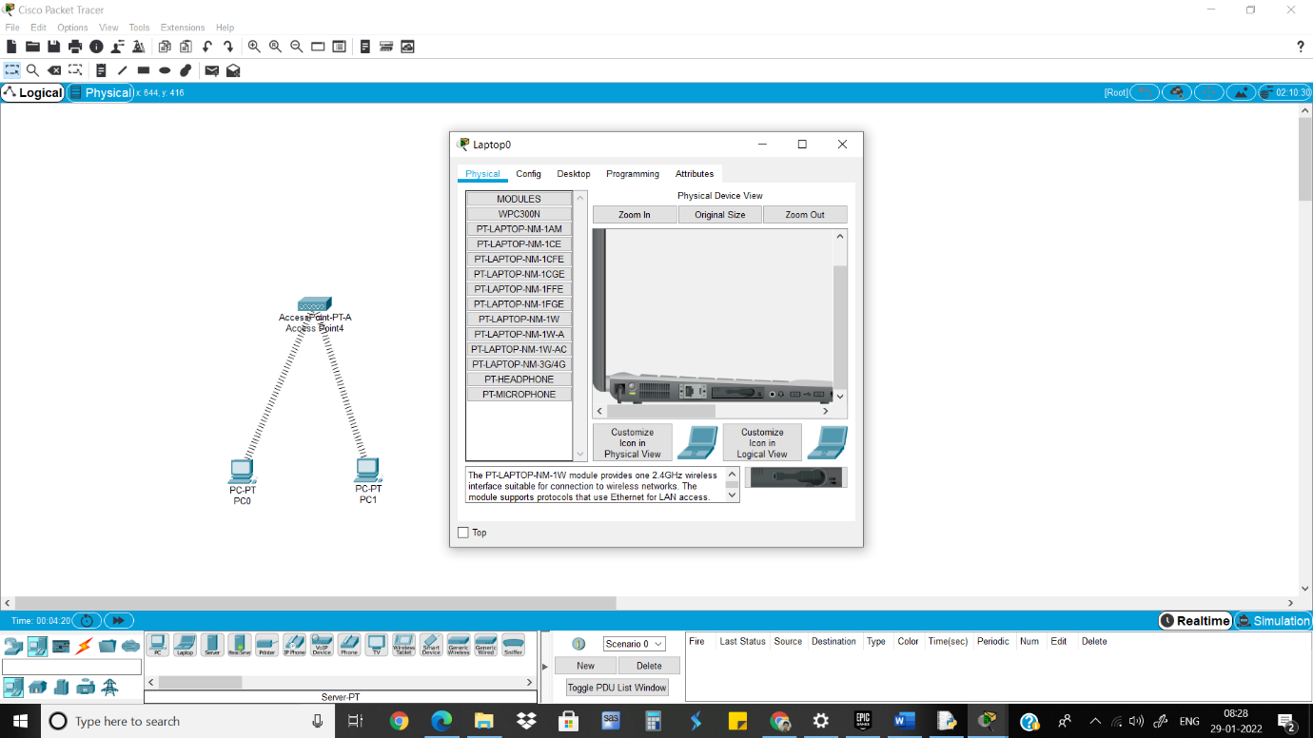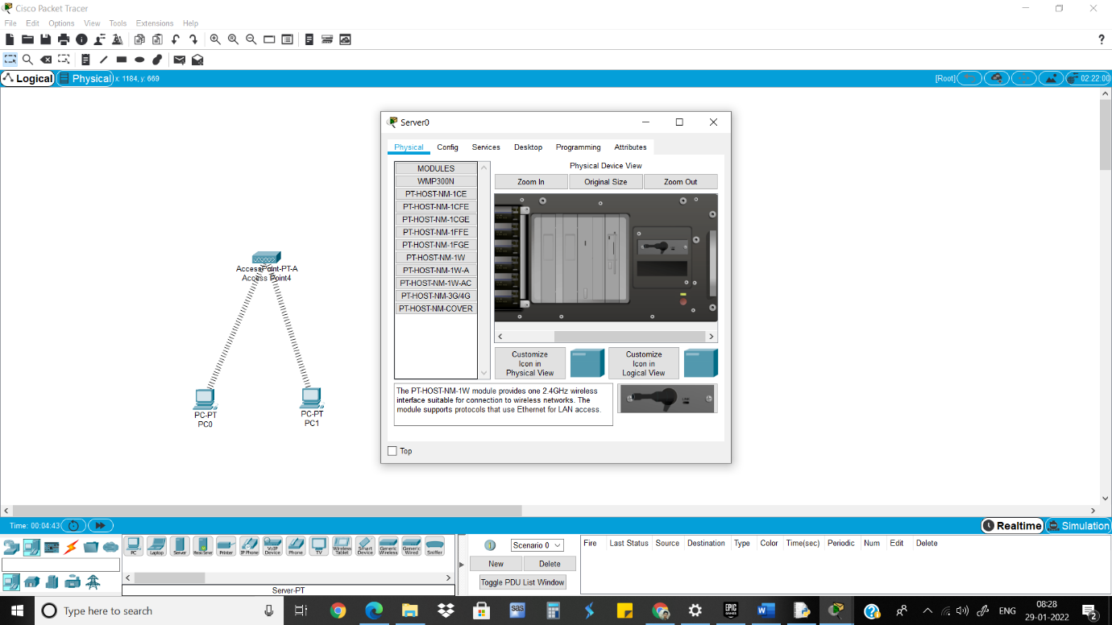

3)Give IP address to each device

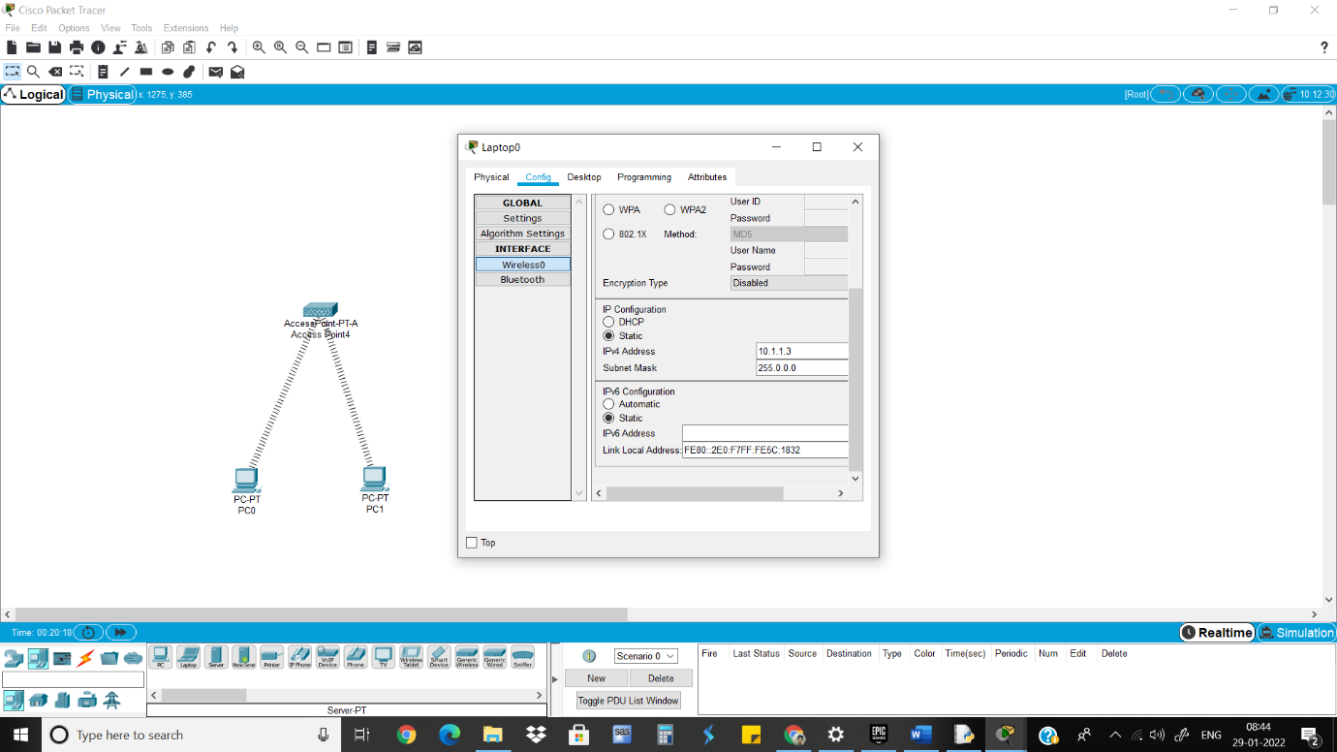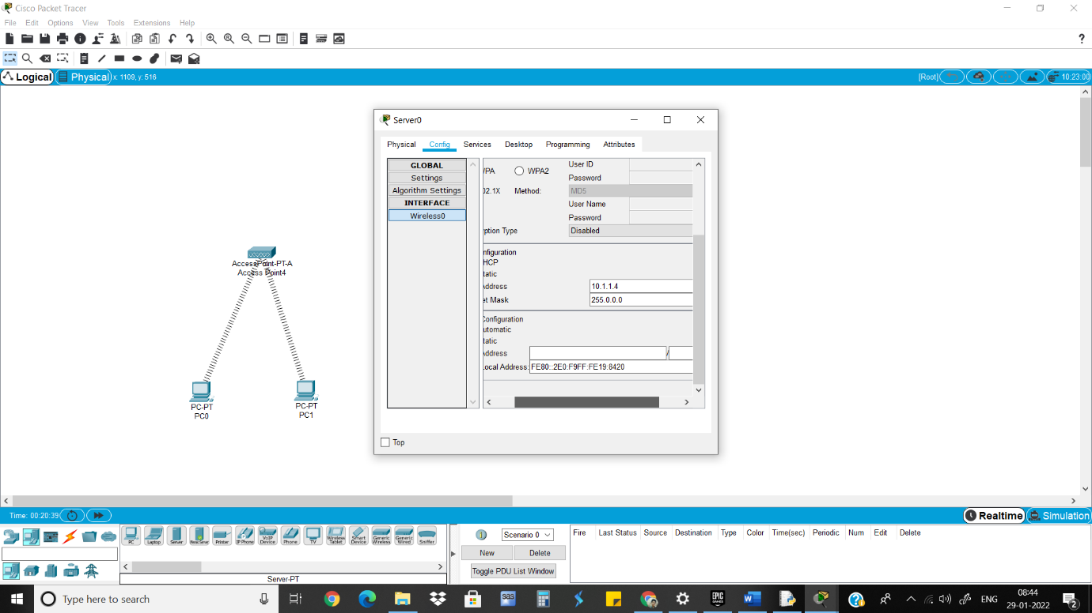

4)Ping Devices

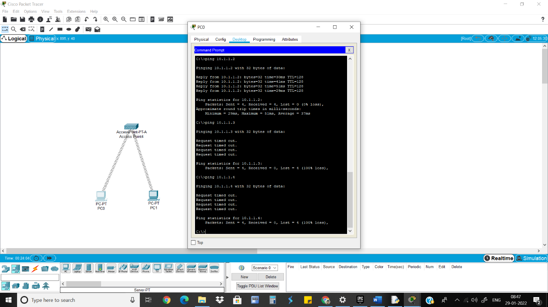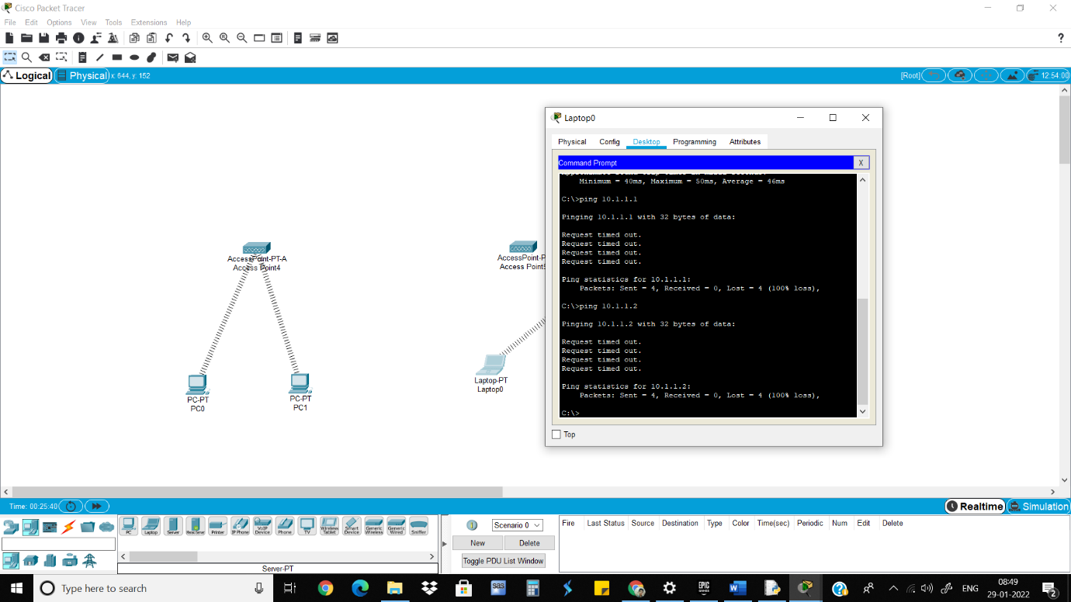

5)Turn off the 1 access point and connect with other

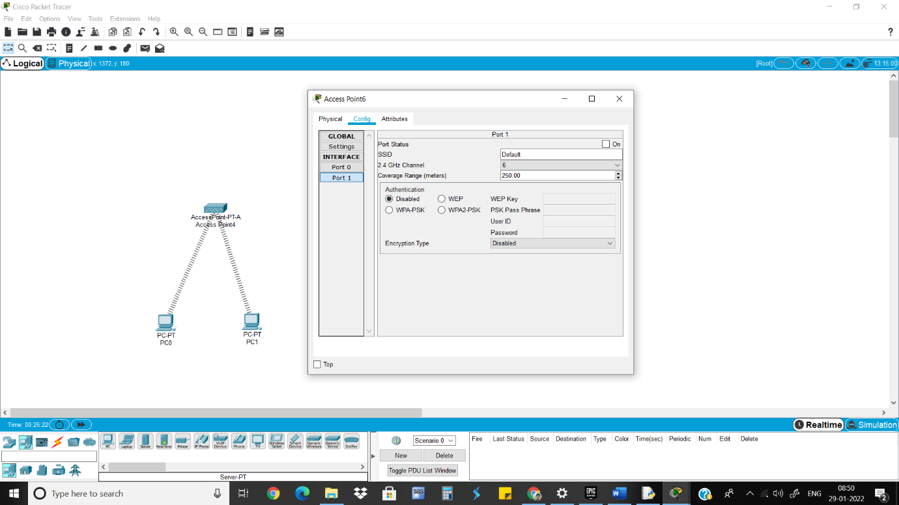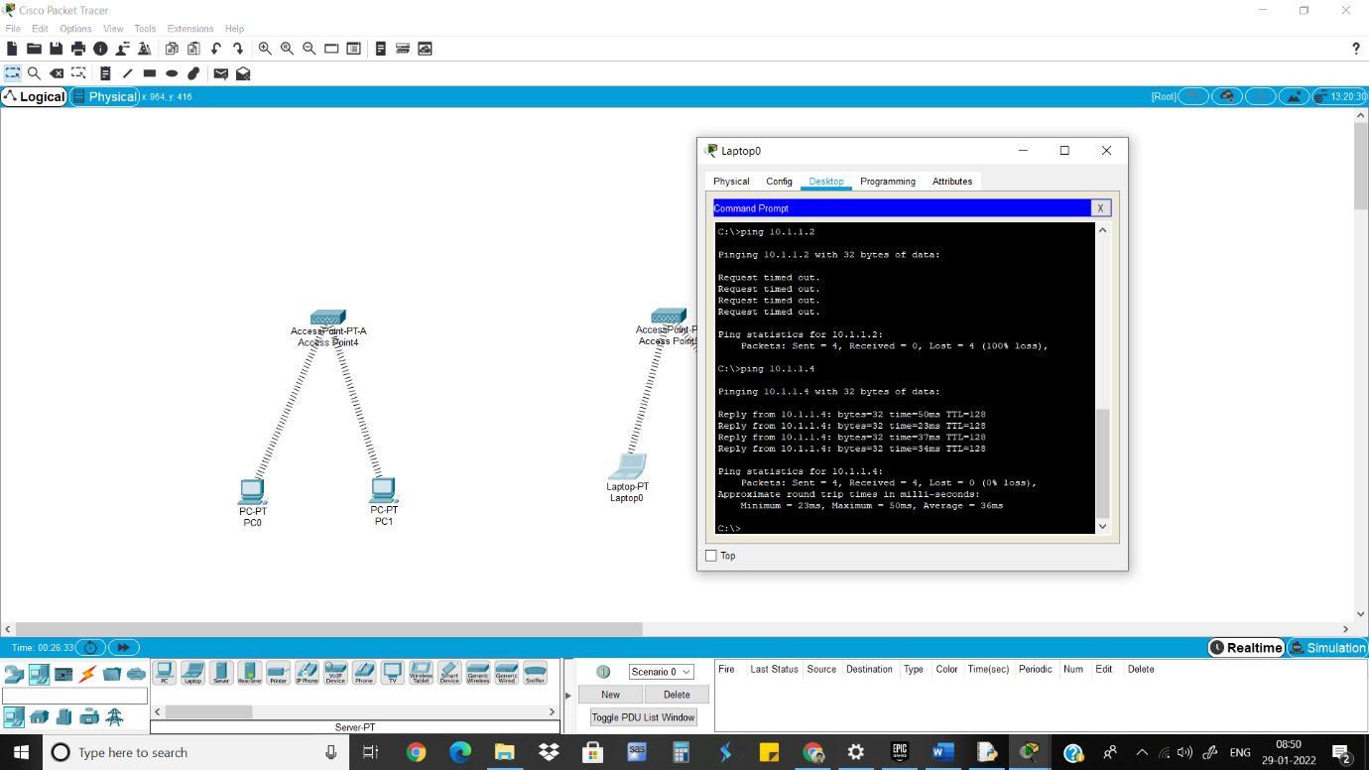

7.2 To demonstrate the Wireless Access between the Access Point

1)Take 1 Router, 2 Access points, 2 Tablets, 1 Laptop and 1 Smartphone

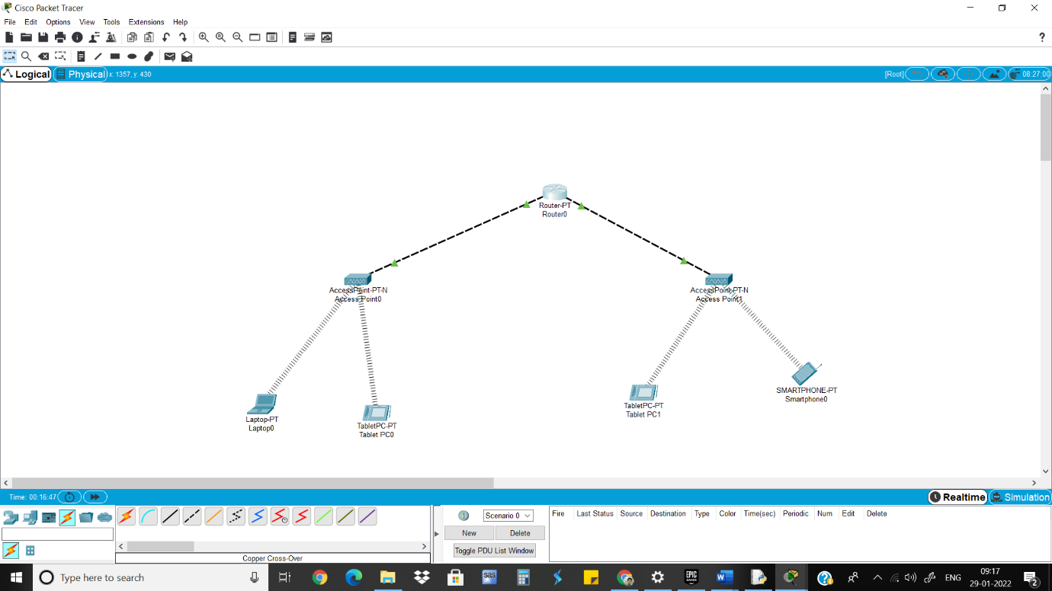

2)Connect Access points with Router and give IP address 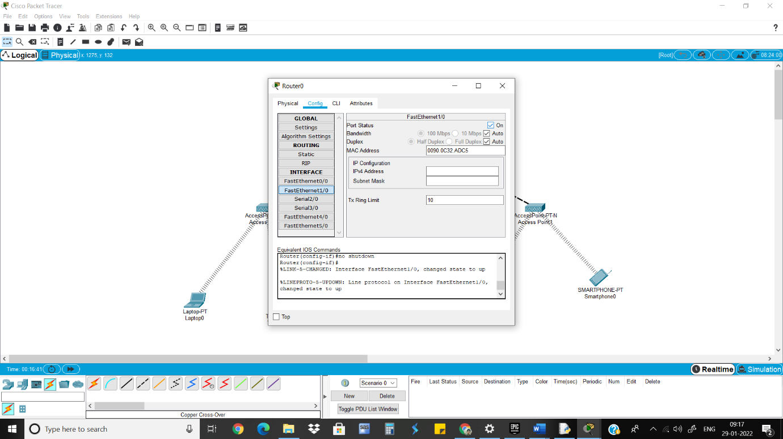

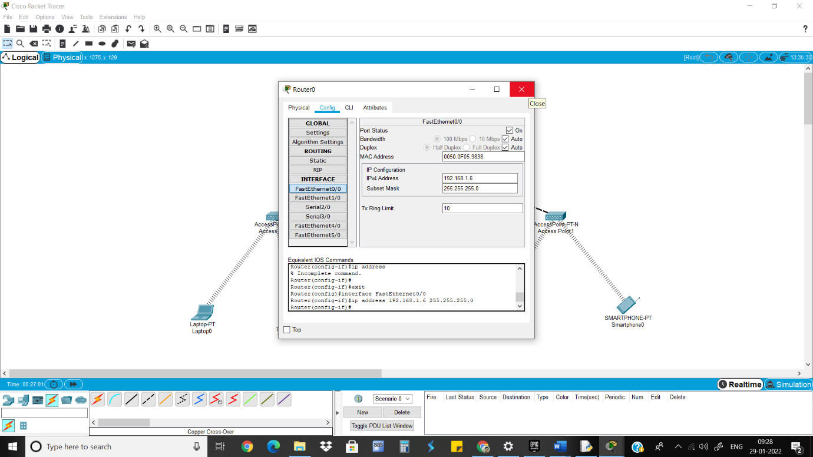

3)Give IP address and default gateway to rest of the devices 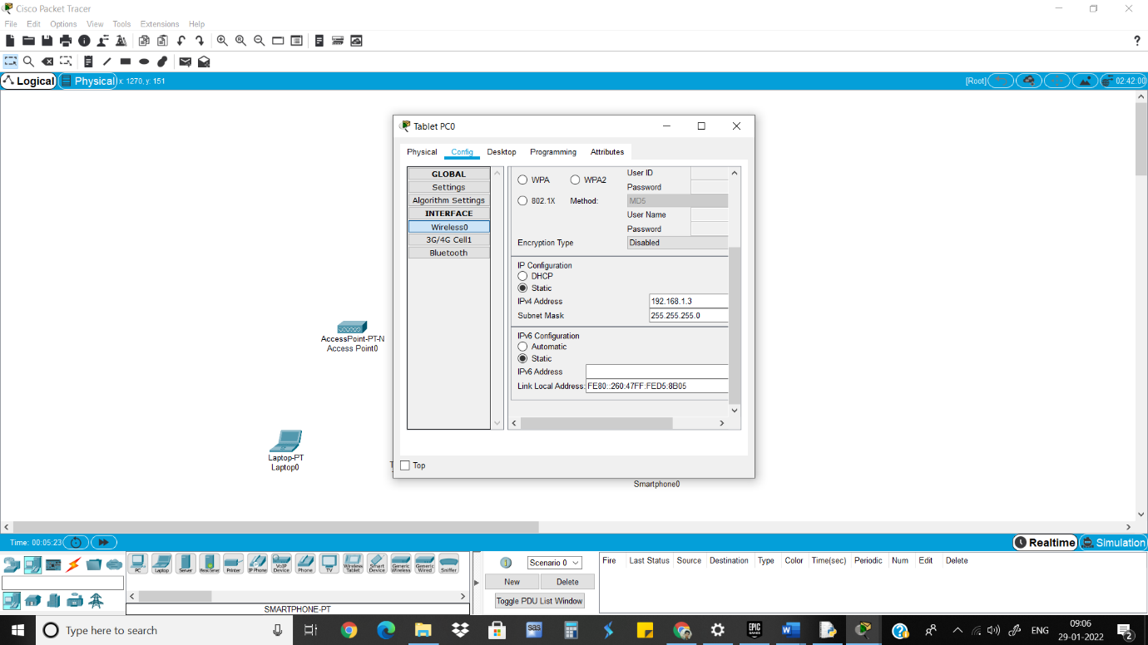

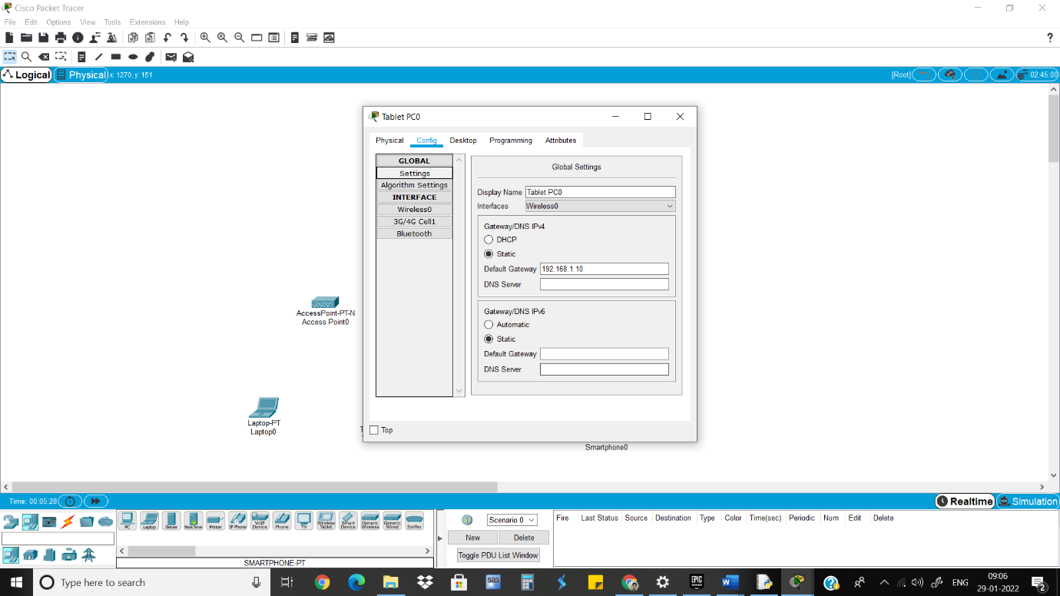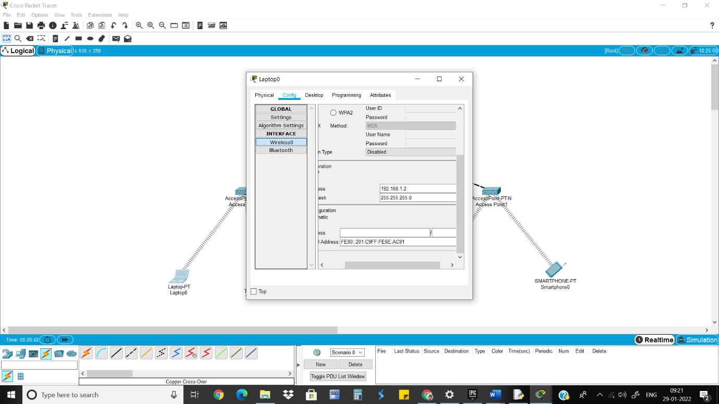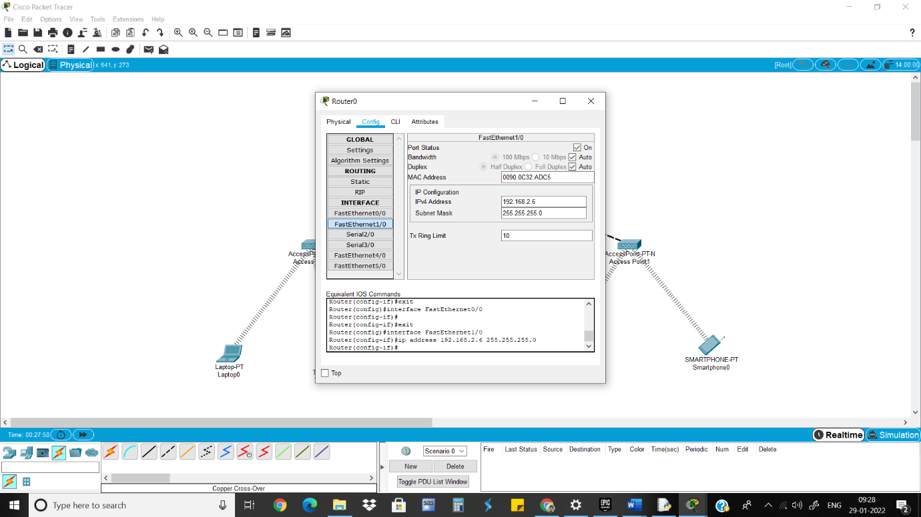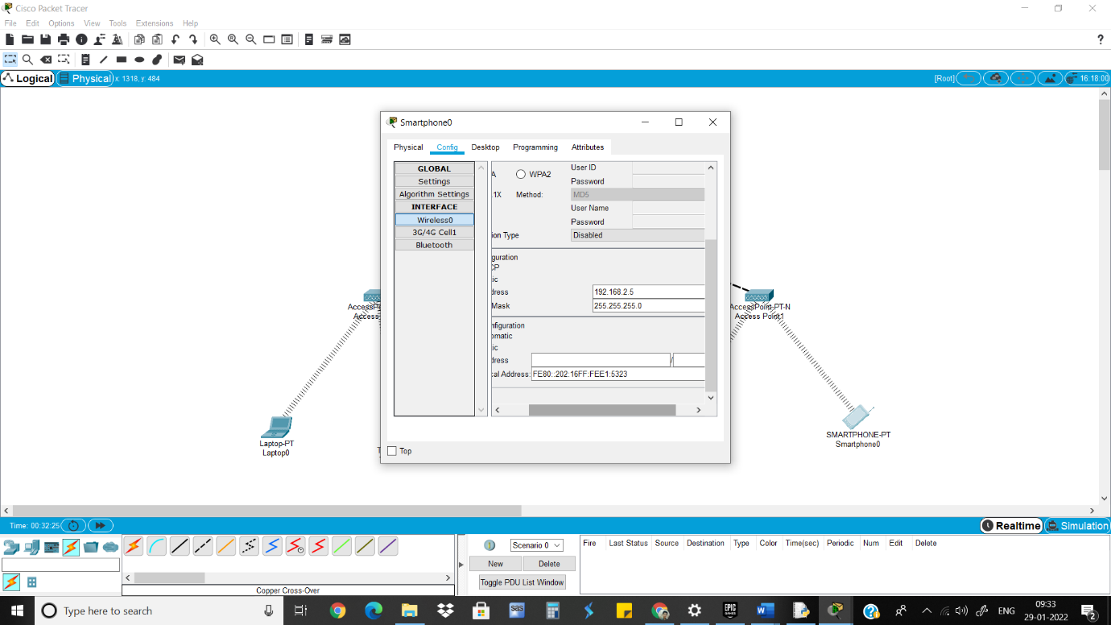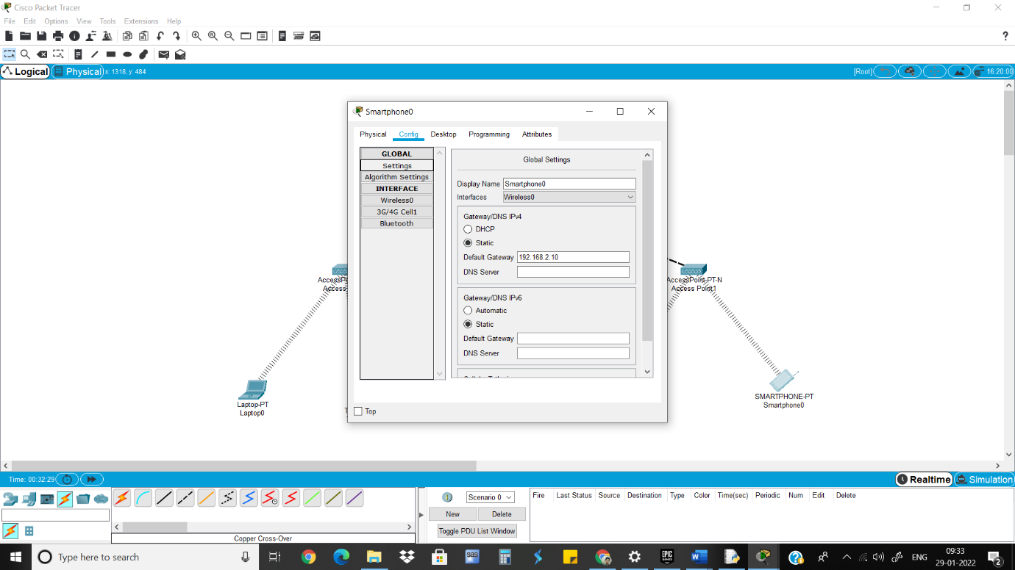

4)Ping Devices

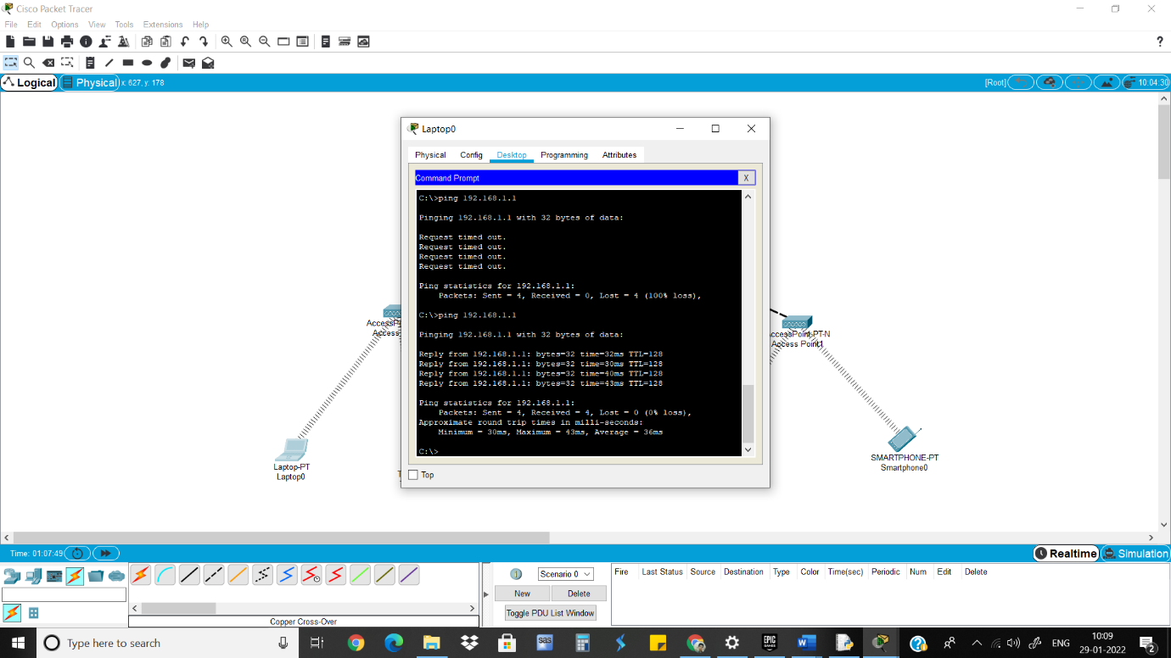

Neeraj Appari T073

Wireless Sensor Networks and Mobile Communication Practical 8

Aim: Create MAC protocol simulation implementation for wireless sensor Network.

1)Take 1 Router, 3 Laptops, 2 Smartphones and 1 Tablet.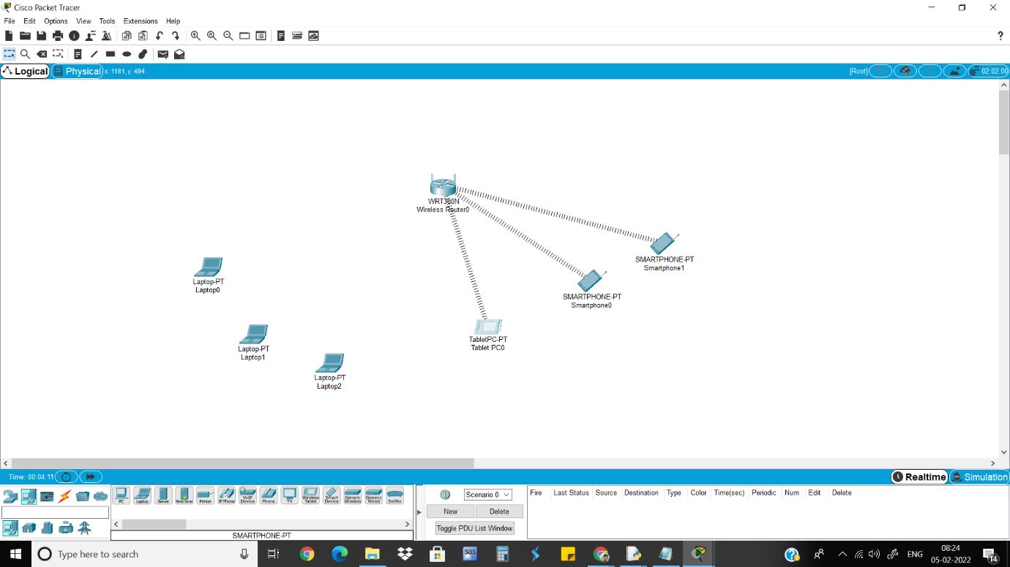

2)Adding the wireless port to each laptop so they connect to the router.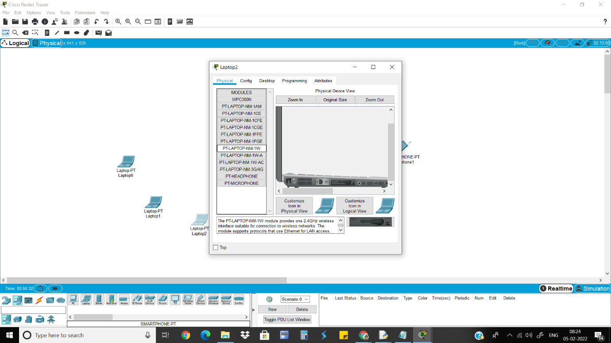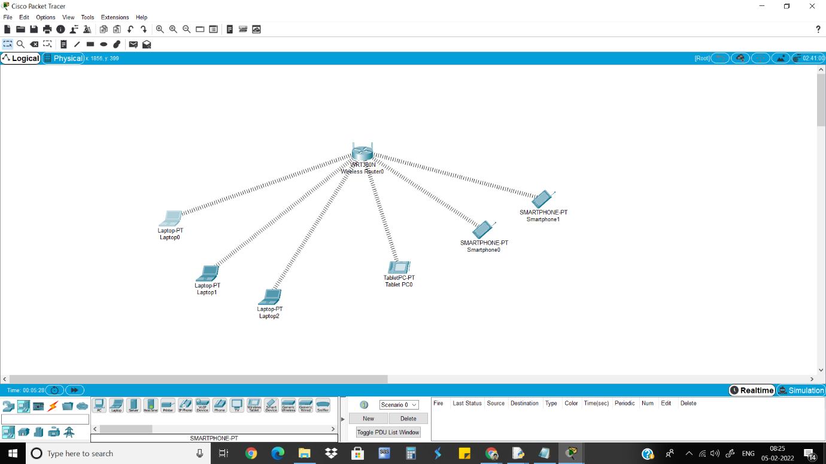

3)Copy the MAC address of each device.

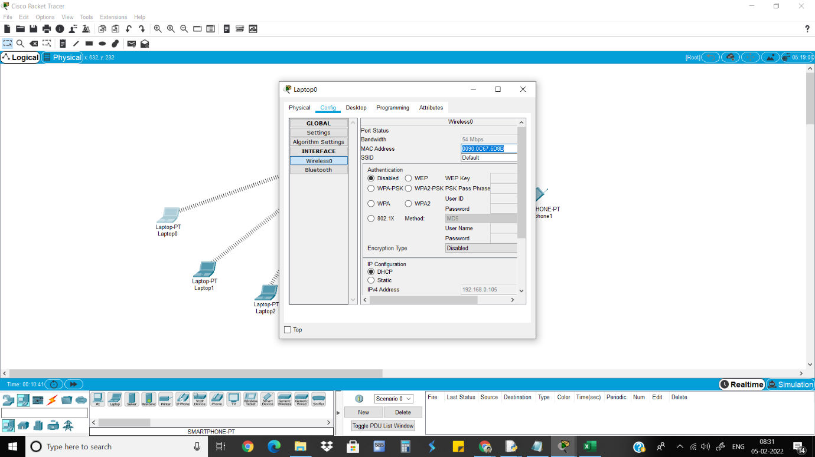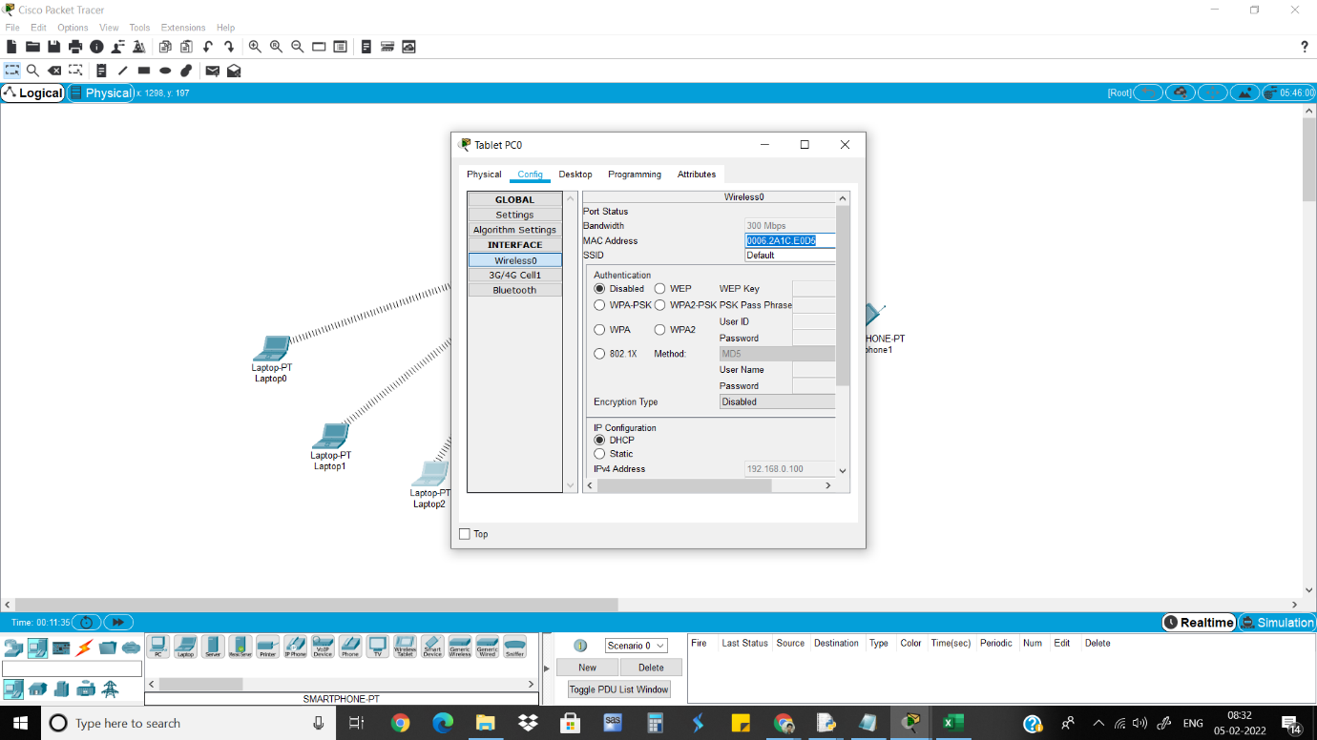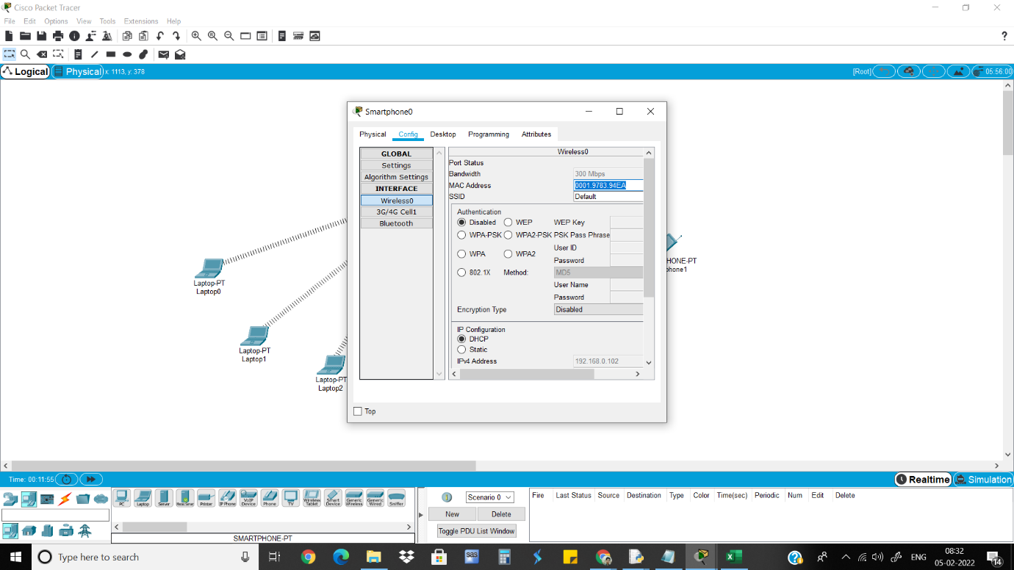

4)Convert MAC address.

5)Go to Router>GUI>Wireless>Wireless MAC Filter and give MAC address that needs to be prevented connecting.

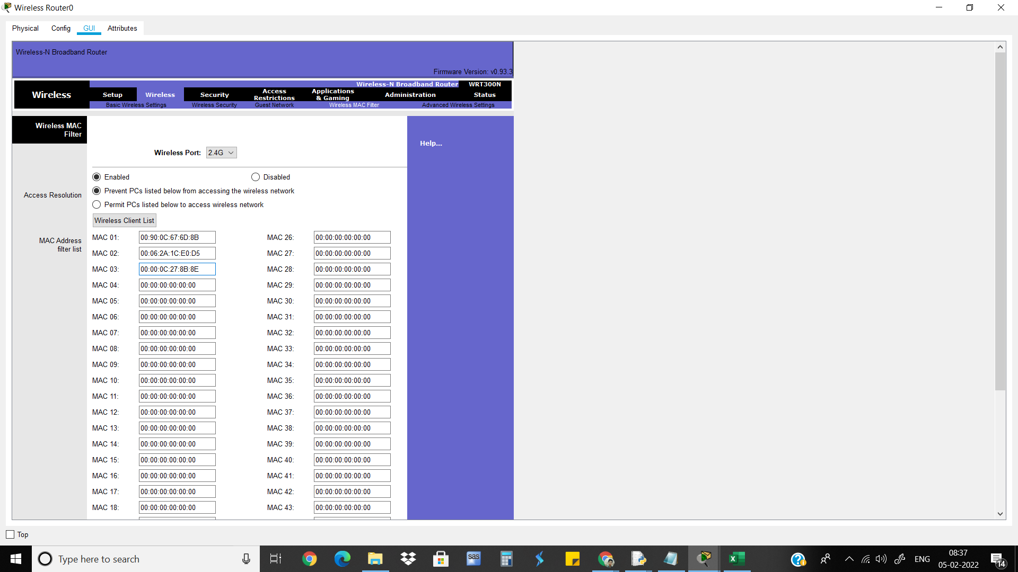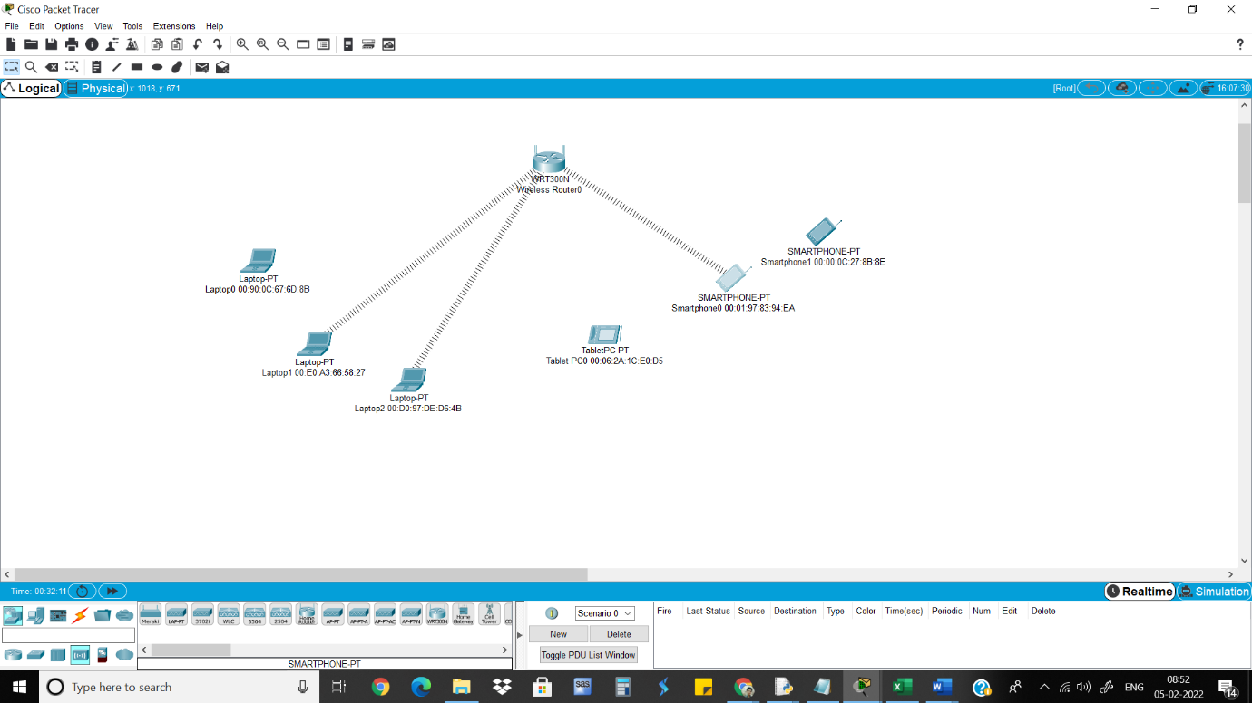

6)Then Give MAC address to permit the devices that needs to be connected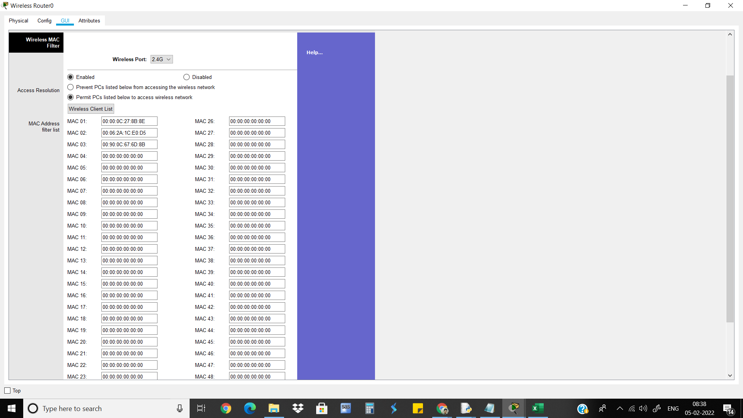

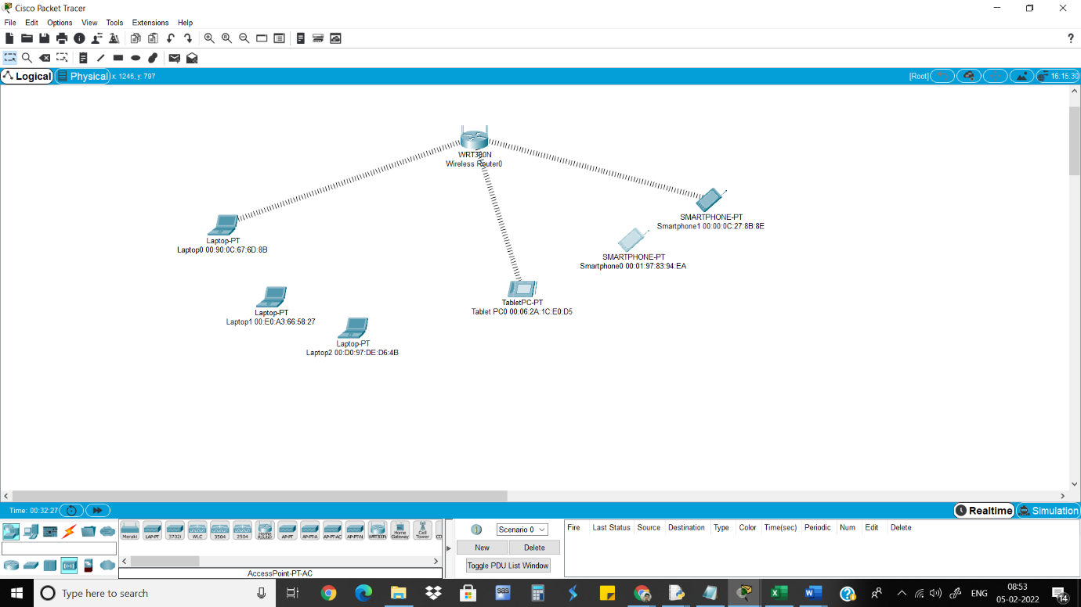

Neeraj Appari T073

Wireless Sensor Networks and Mobile Communication Practical 9

Aim: Simulate Mobile Adhoc Network with Directional Antenna

Steps:

1)Consider the following topology.

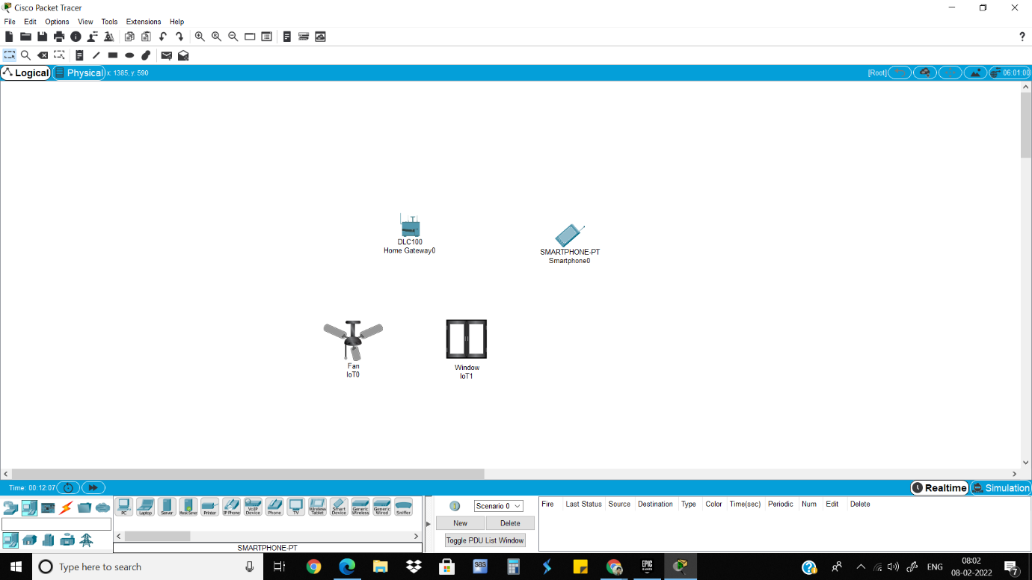2)Go to fan>config and change dnsgateway to dhcp and automatic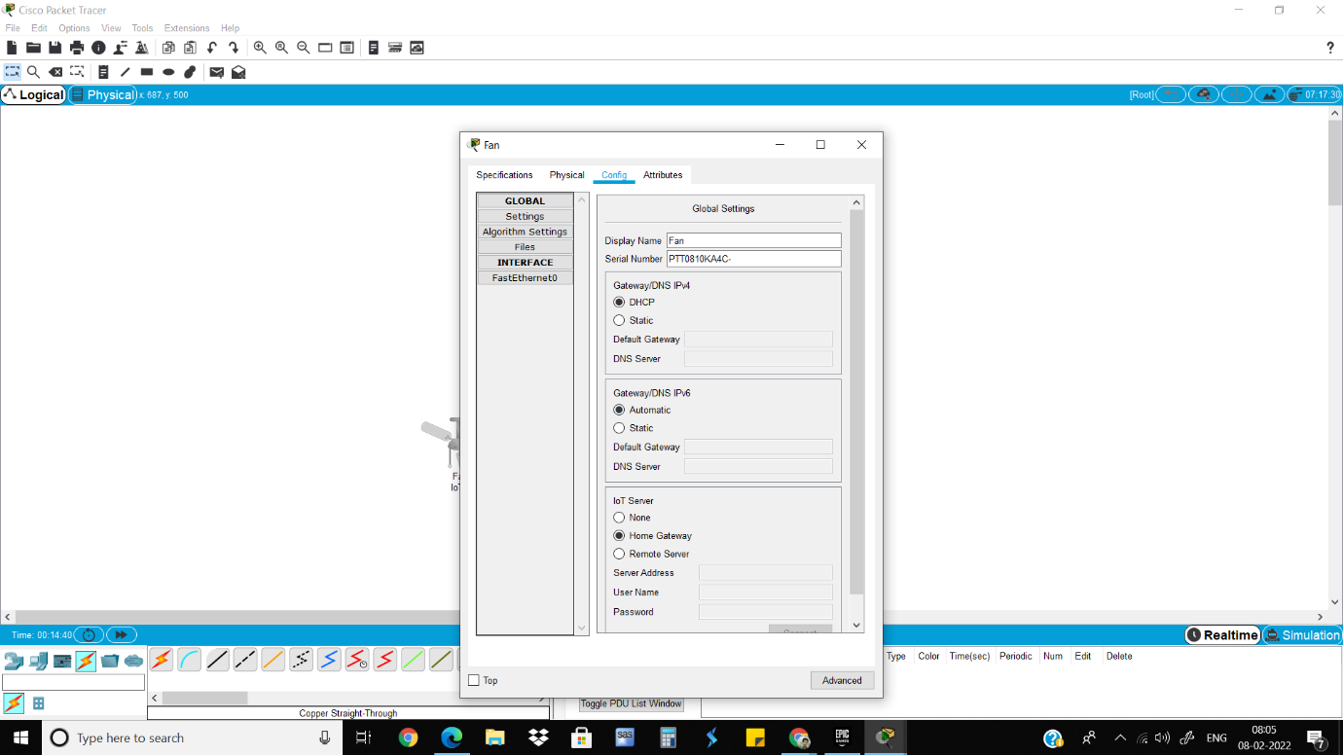 3)Go to advanced setting>i/o config and change the network adapter to PT-IOT-NM-1W. 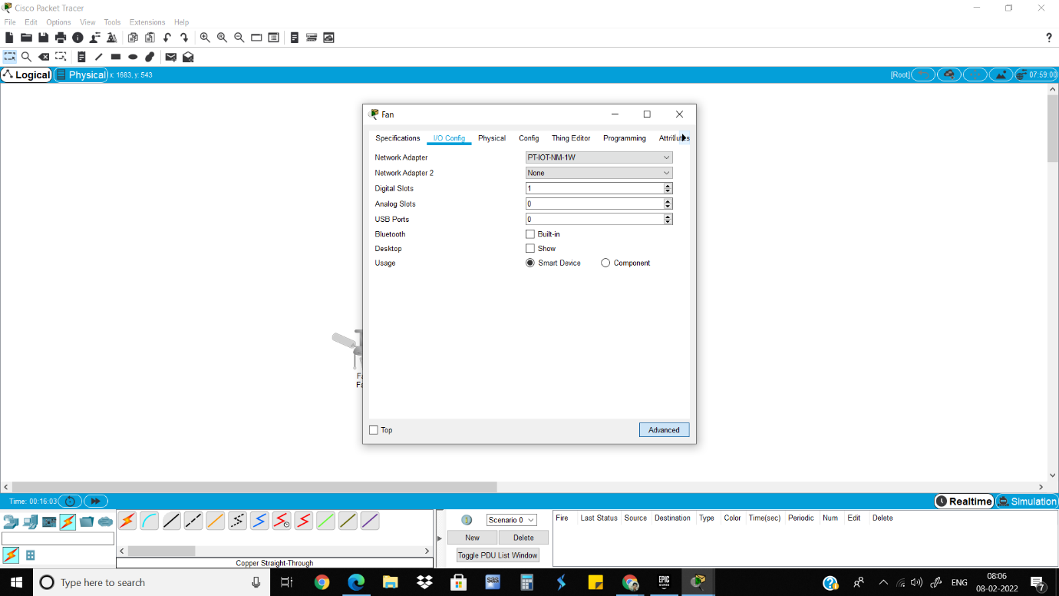4)Do the same steps for window. 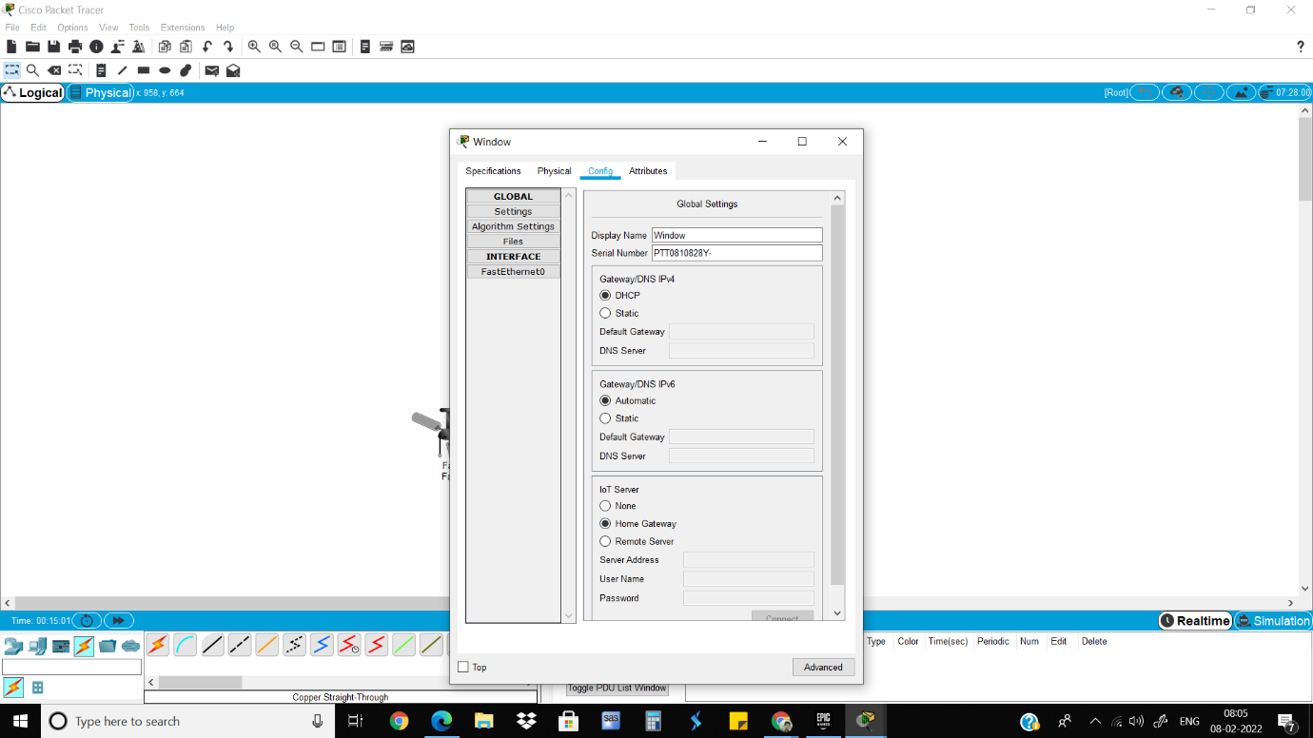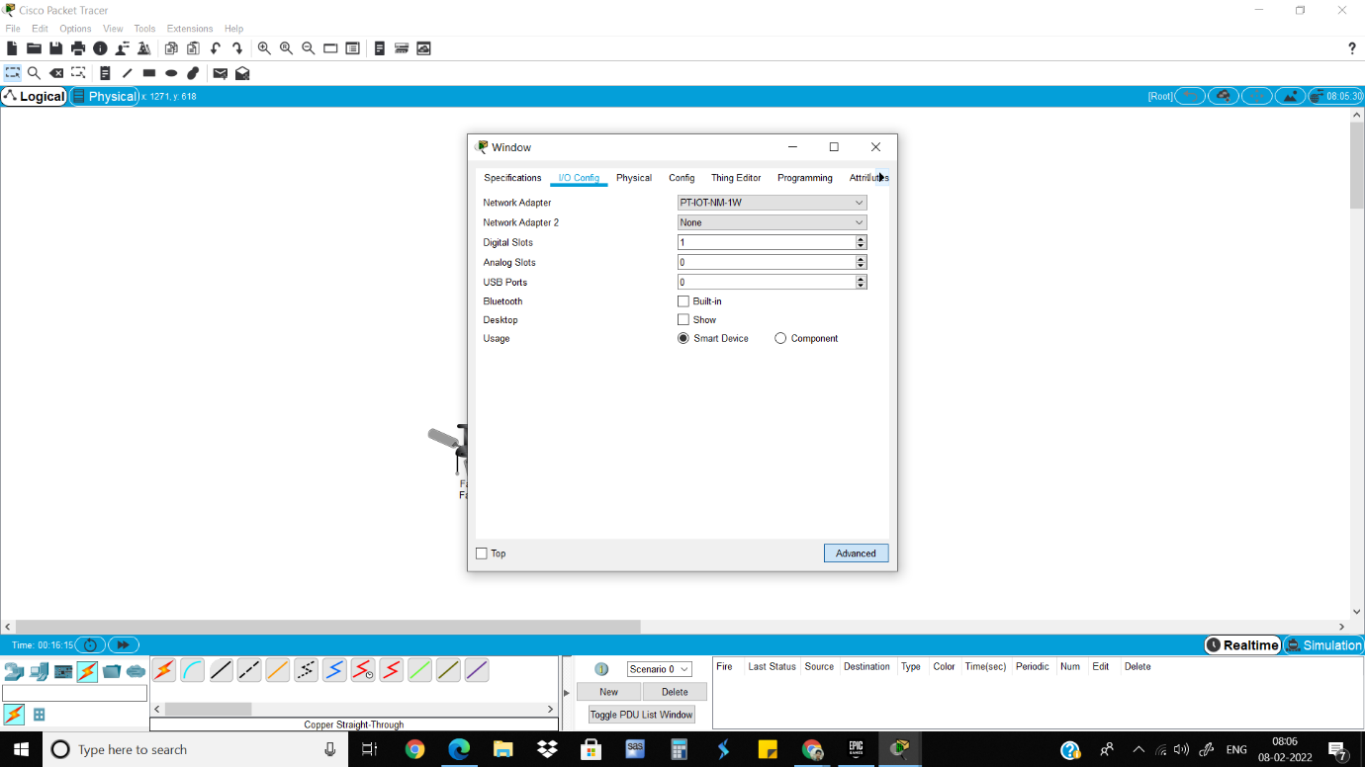5)Go to smartphone>config and give the same SSID as the home gateway.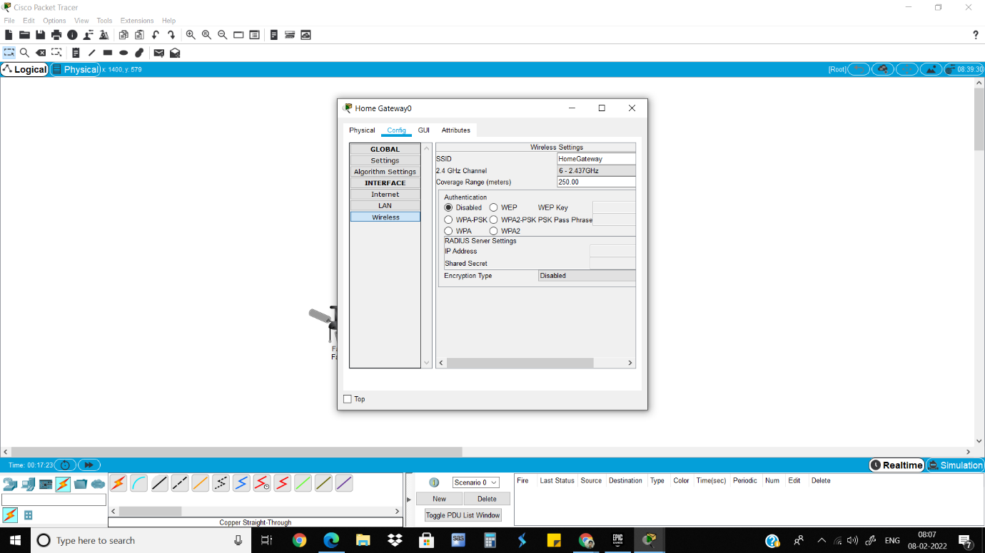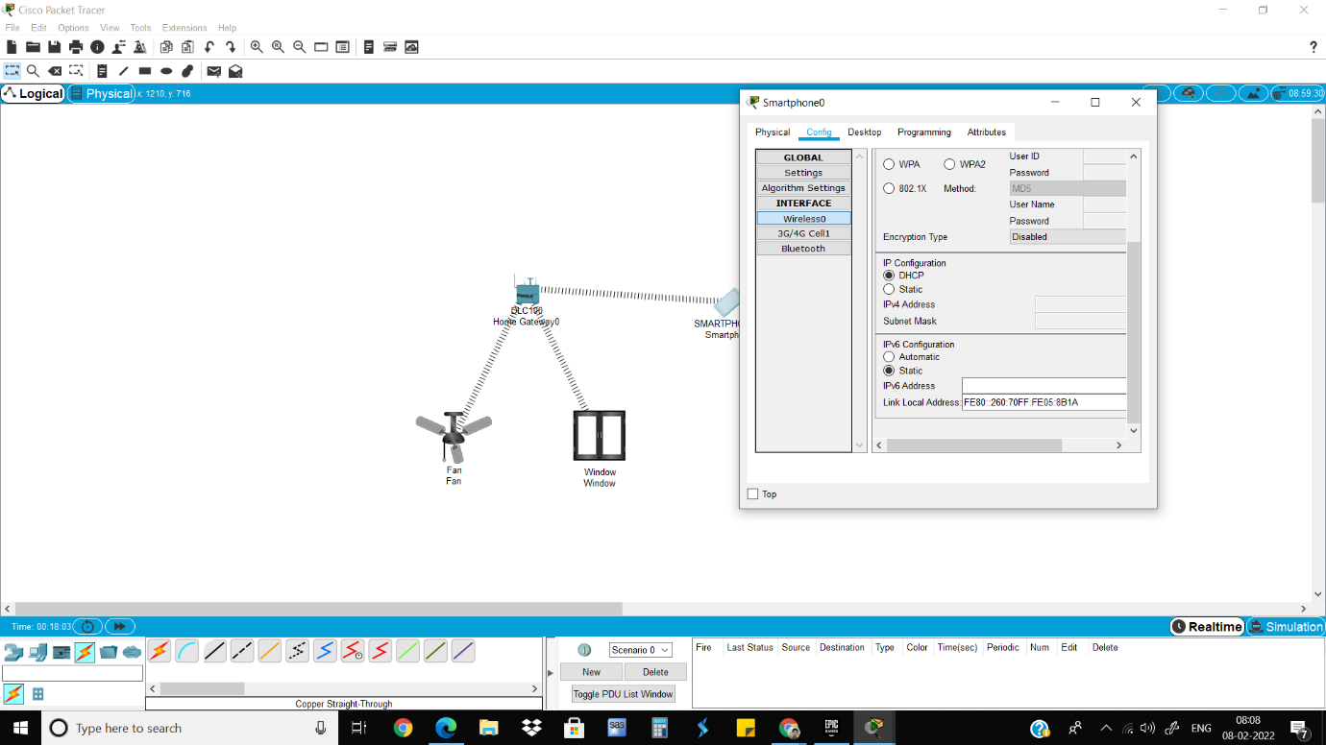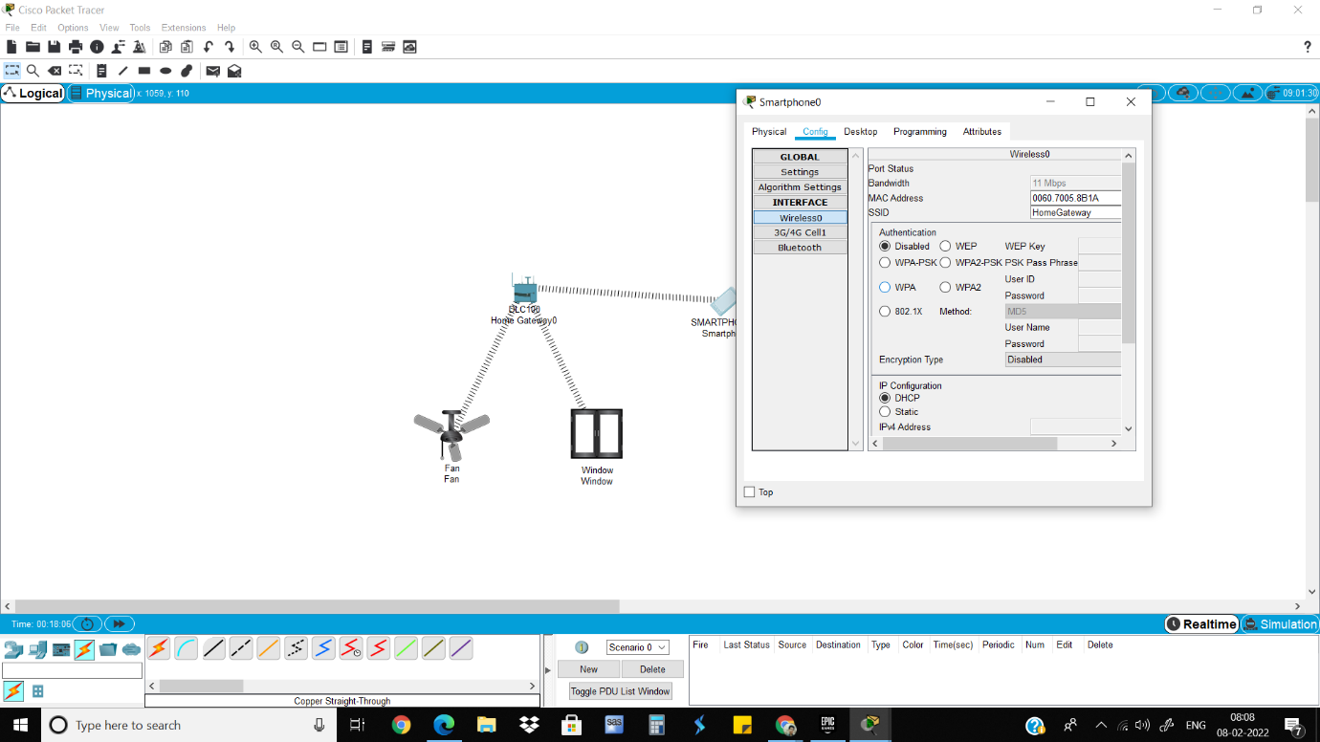 6) Now everything is connected.

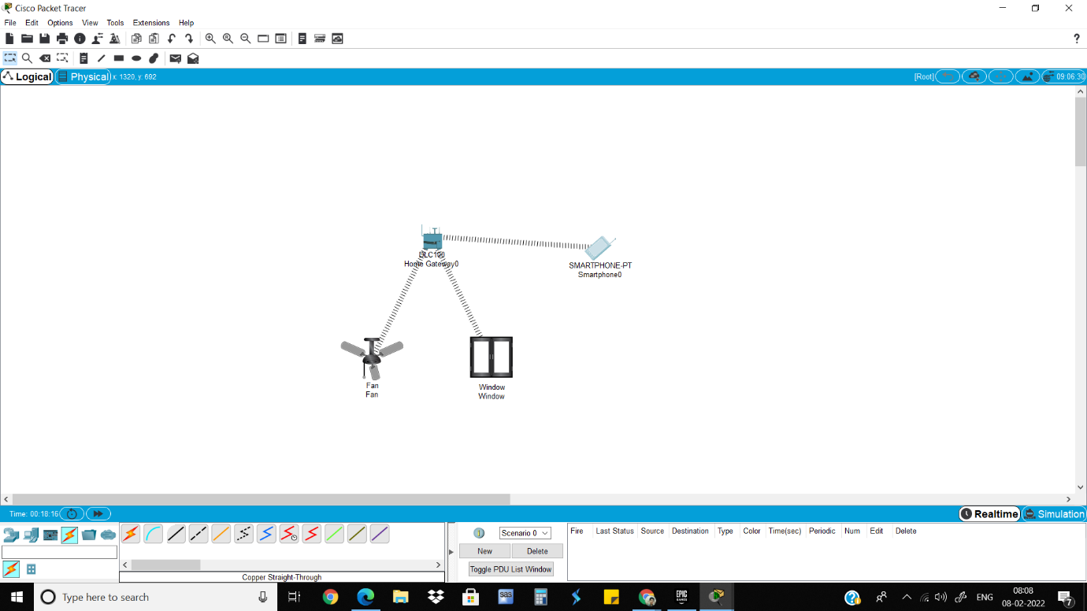7)Go to web browser and give the same IP address as the home gateway. 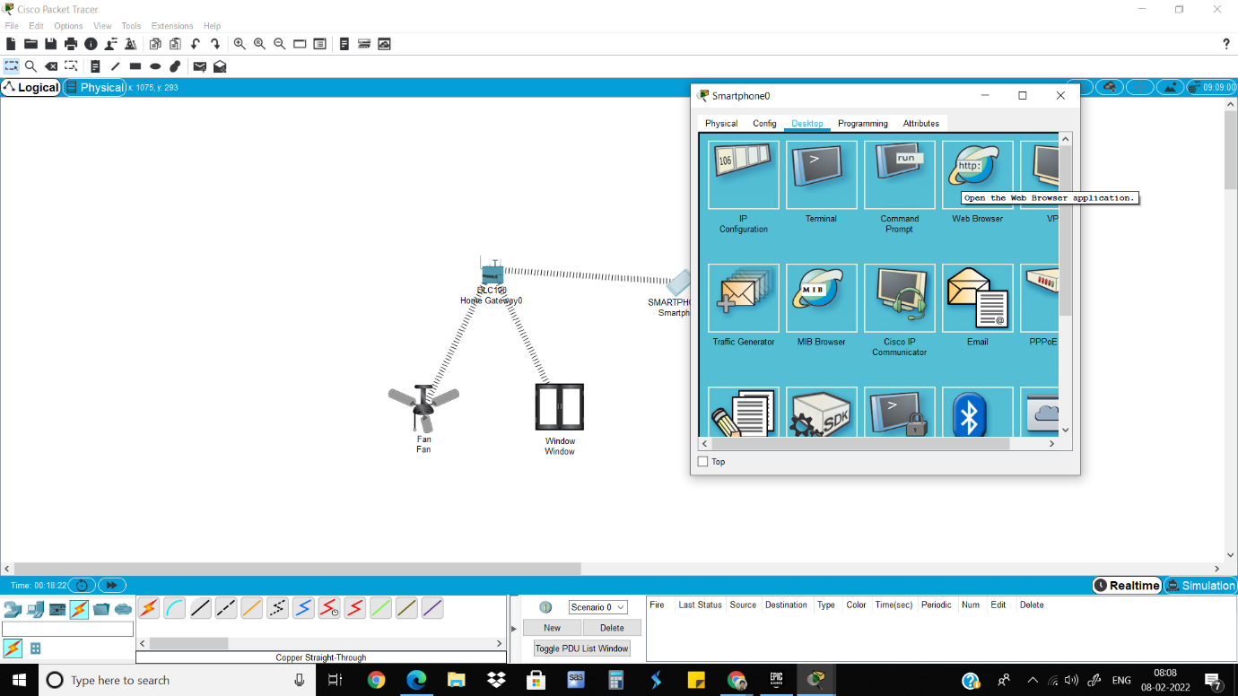

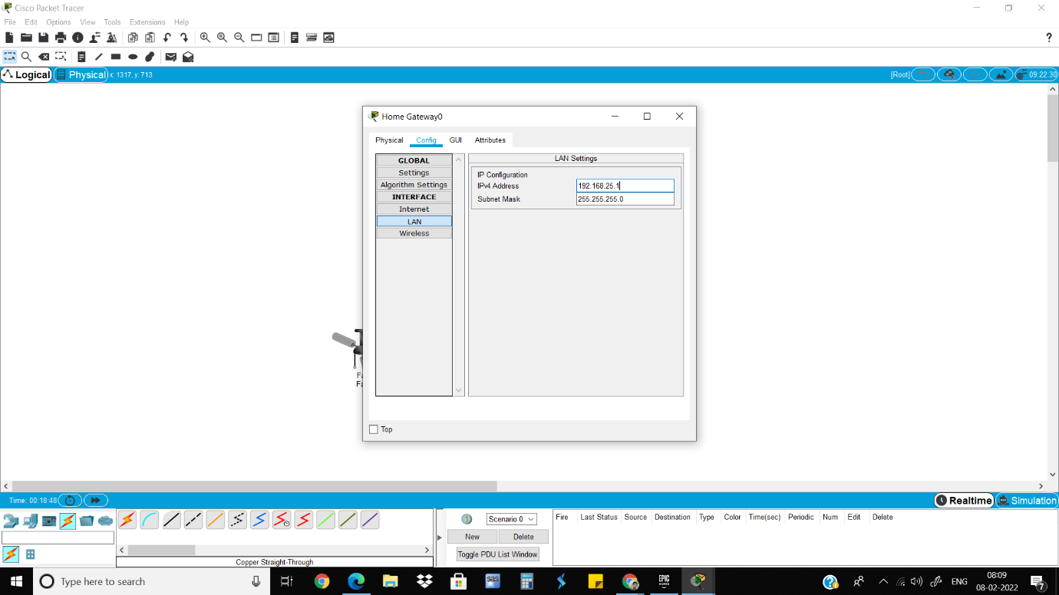8)Give username and password as admin and admin.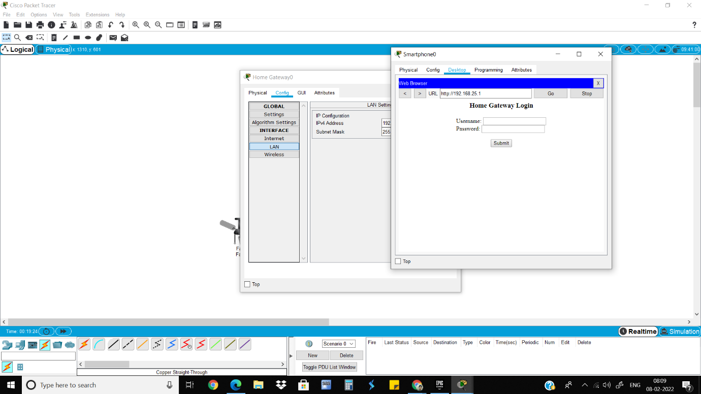

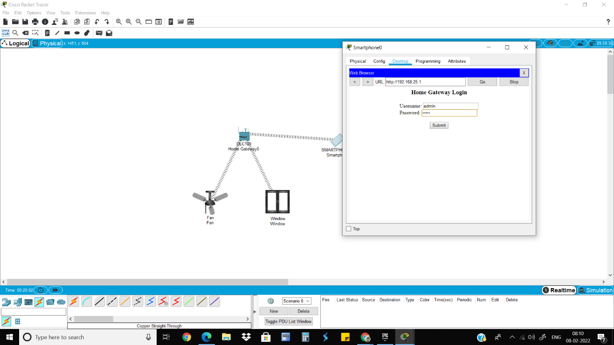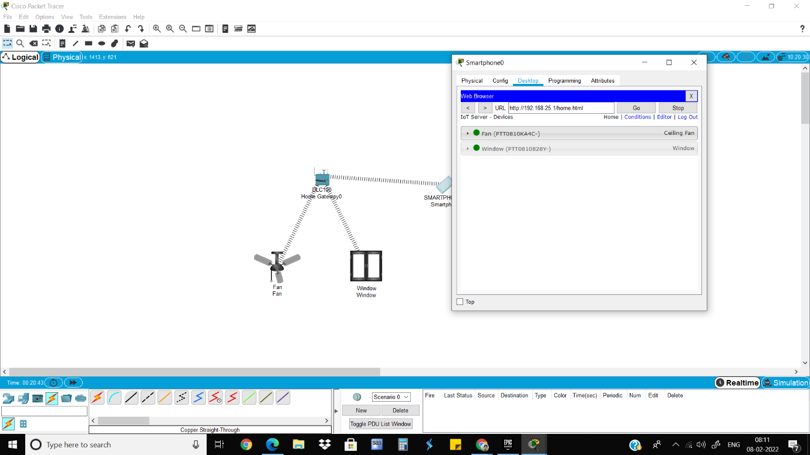9)Go to conditions to give conditions if the conditions are not already set.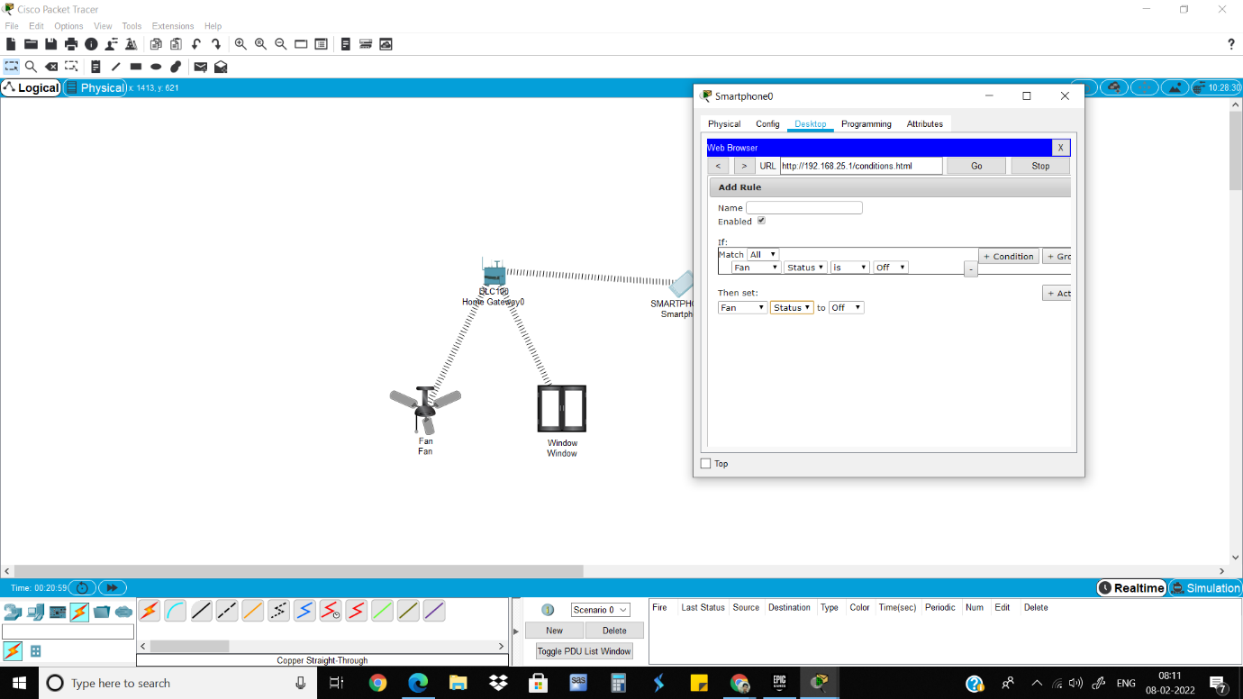 10)Demonstrate turning on the fan at high speed and low speed and opening the window. 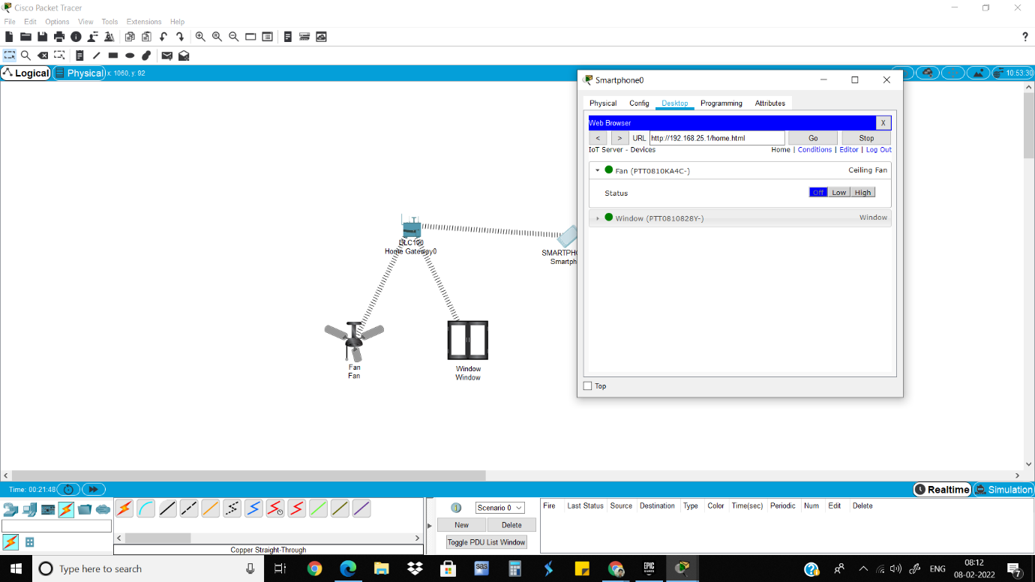

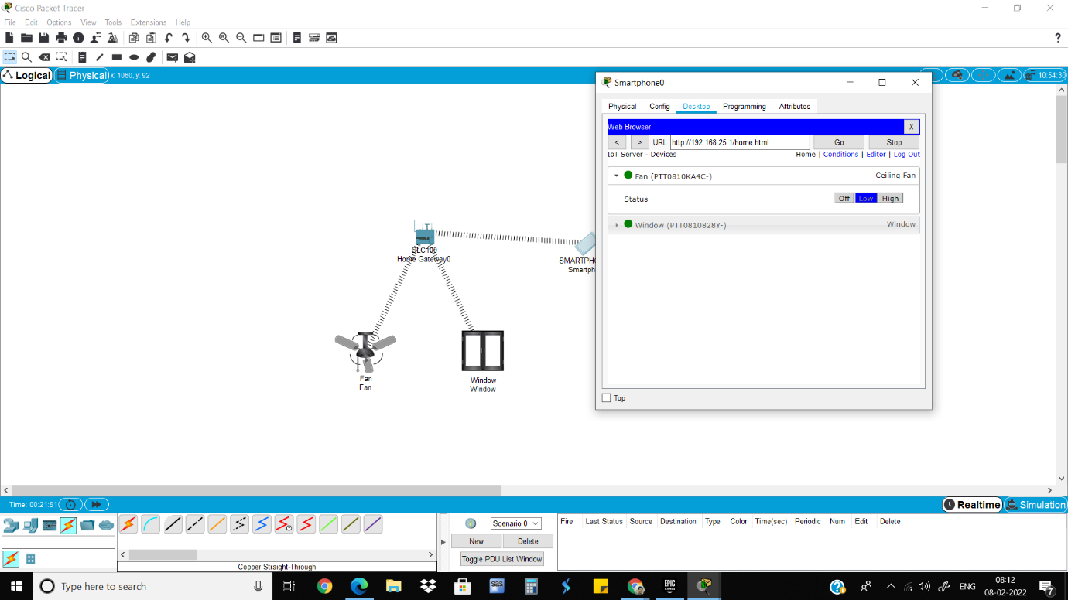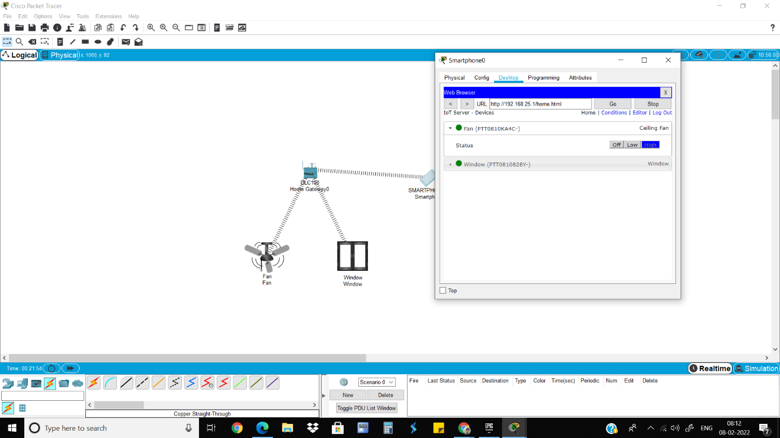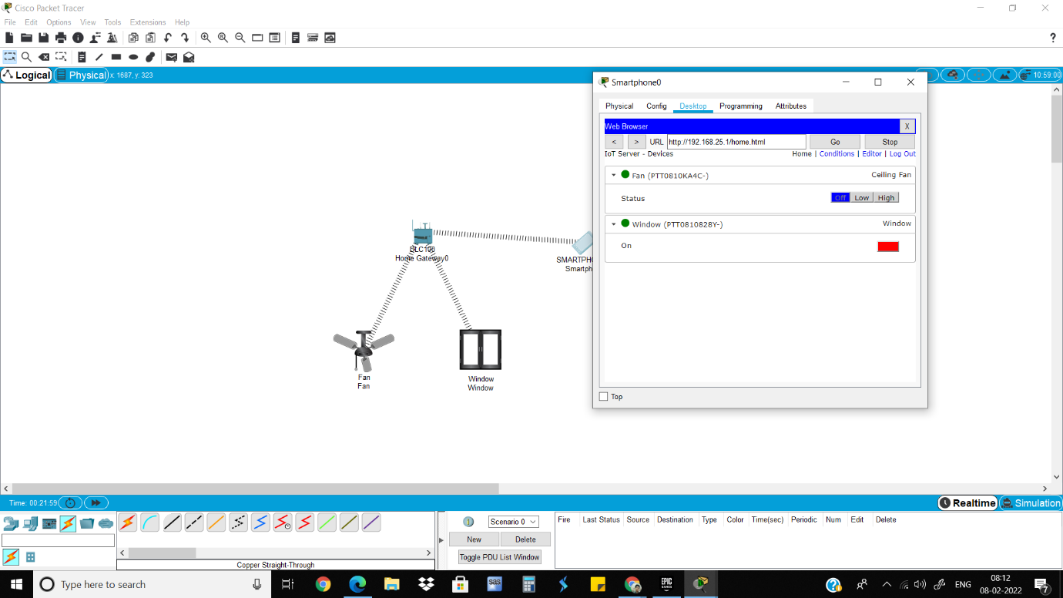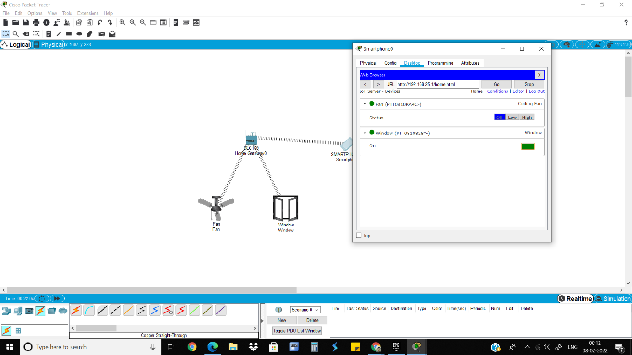

Neeraj Appari T073

Wireless Sensor Networks and Mobile Communication Practical 10

Aim: Create a network using smartphone, wireless router WRT300N, Hub-pt, 1841 Router, central office-server, Cell-Tower. Simulate connection between them

Connect cell tower and central office server using coaxial cable. 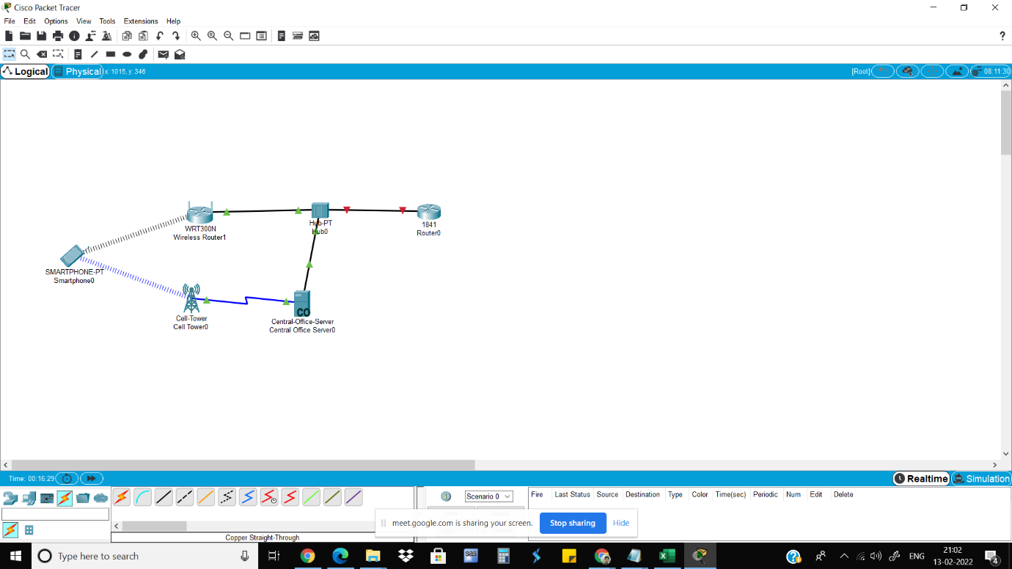 Connect wireless router WRT300N, Hub-pt, 1841 Router, central-office-server using copper

straight through wire.

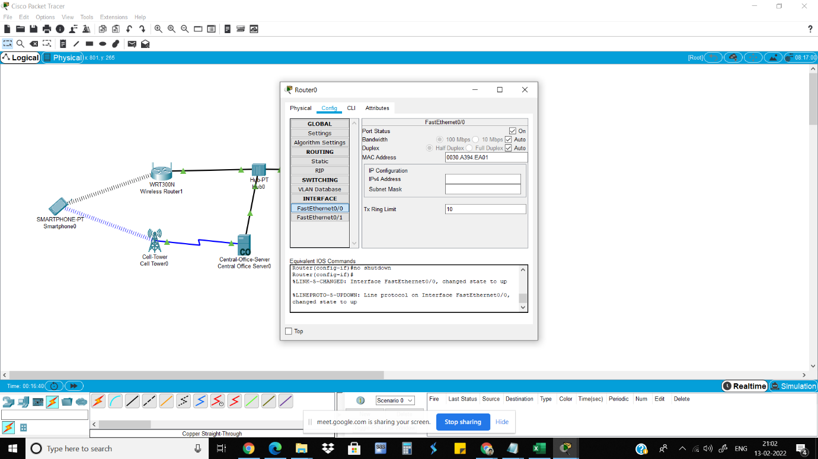

Click on wireless router.in config tab select internet.in internet choose ip configuration as static

and set IP address and default gateway

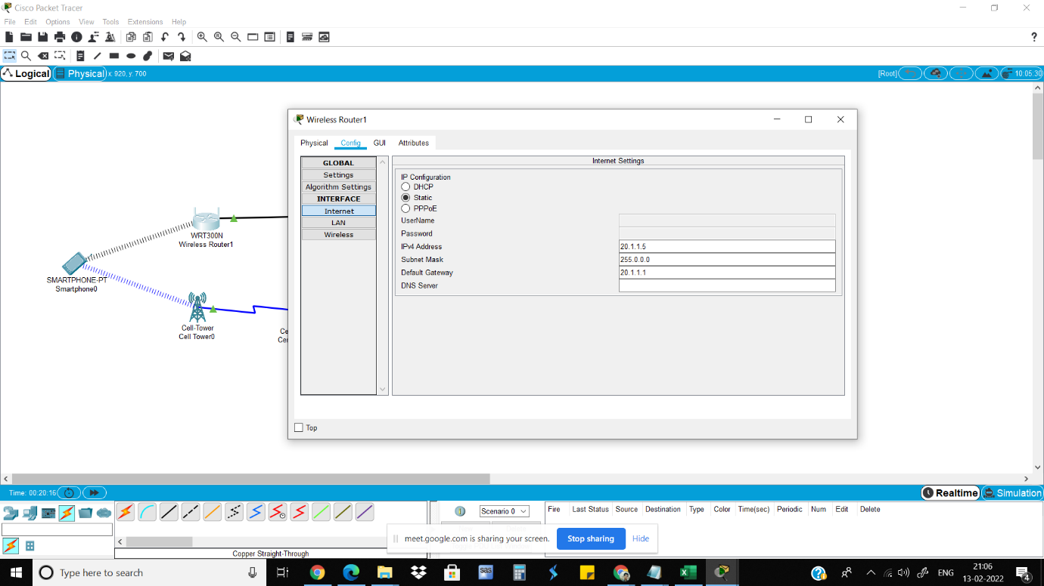

Click on router 1841. In config tab select interface and give IP address

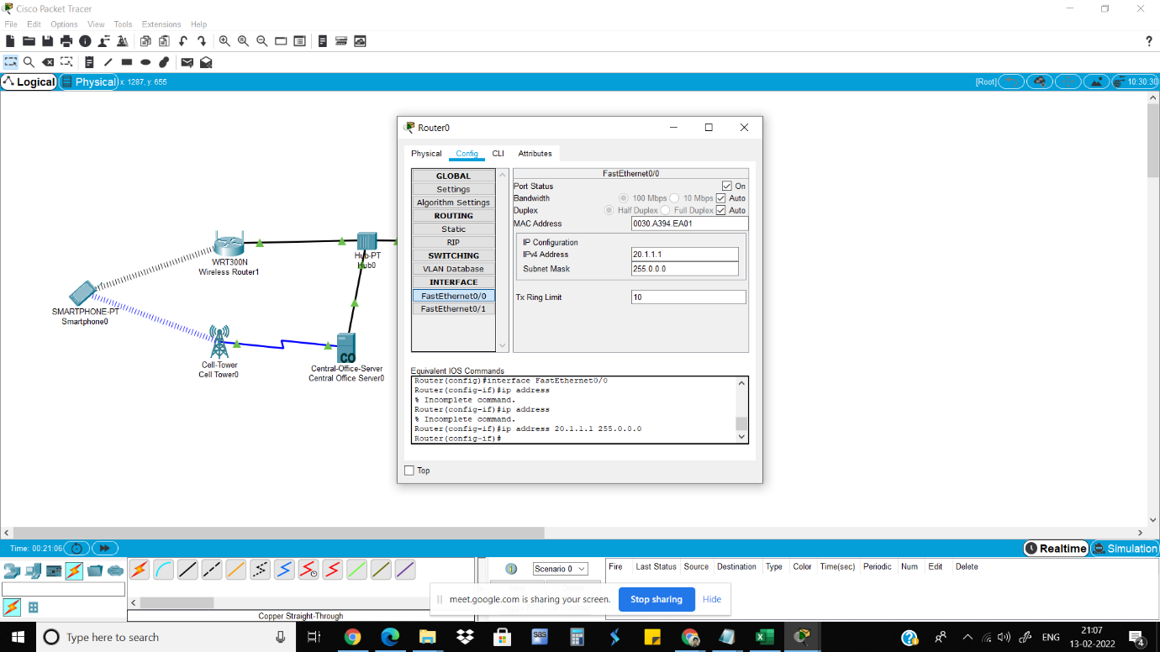

Click on smartphone and ping router1841

